Government of Libya

Accounting Concepts, Principles and Policies

Accounting & Procedures Manual
Volume 1
Version 1.0

Release Date:
31 December 2013
99912

Contents
Contents i
Part 1 – Accounting Concepts and Principles 1
1. Overview – Purpose and Scope of the Accounting & Procedures Manual 1
1.1 Structure of Accounting Manual 1
1.2 Authority, distribution and maintenance of the Manual 1
1.3 Purpose of Volume 1 - Accounting Concepts, Principles and Policies 1
1.3.1 Structure of Volume 1 of the Manual 2
2. Accounting Concepts 3
2.1 Generally Accepted Accounting Principles (GAAP) 3
2.1.1 Accounting Principles 4
2.1.2 International Public Sector Accounting Standards 4
2.2 Accounting period 4
2.3 Accounting records 4
2.4 Accounting elements 4
2.5 Accounting equation 5
2.6 Accrual vs cash based accounting 5
3. Accounting Principles 6
3.1 Double entry book-keeping 6
3.1.1 The Accounts 6
3.1.2 Debits and Credits 7
3.2 Journals 10
3.2.1 Illustrating the Accounting Journal 10
3.2.2 Special Journals 12
3.3 The General Ledger 13
3.3.1 The Ledger Concept 13
3.3.2 Posting 14
3.4 The Trial Balance 15
3.4.1 T-Accounts 17
3.5 Financial Statements Reporting 18
3.5.1 Consolidated Financial Statements 18
3.5.2 Statement of Cash Receipts and Payments 19
3.5.3 Statement of Comparison of Budget to Actual 19
3.6 Chart of Accounts 19
3.6.1 What Should the Chart of Accounts Include? 19
3.6.2 Features of a Simple Chart of Accounts 21
3.6.3 Capturing More Complex Financial Information 22
3.7 Subsidiary ledger and registers 24
3.8 Petty Cash 25
3.8.1 Establishing a Petty Cash Fund 25
3.8.2 Replenishing the Petty Cash Fund 25
3.8.3 Petty Cash Internal Controls Checklist 26
3.9 Bank Reconciliations 26
3.10 Government Assets 27
Attachment 1 – Accounting Concepts 1
A. Fundamental Concepts 1
B. Basic Accounting Records 4
C. Accounting Elements 5
D. Illustration of Cash versus Accrual Basis of Accounting 9

Part 1 – Accounting Concepts and Principles

1. Overview – Purpose and Scope of the Accounting & Procedures Manual

Structure of Accounting Manual
This Accounting Manual has been developed with the purpose of drawing together in one place all the information that is required for the staff of the Ministry of Finance and Sectors to undertake their responsibilities with regard to executing, accounting for, and reporting on the approved Government of Libya Budget. The manual is intended to be enduring in nature, subject to regular amendment and additions.
The Accounting Manual is structured in Volumes as follows:
Volume 1 Accounting Concepts, Principles and Policies
Volume 2 Budget Execution Policies and Procedures

Authority, distribution and maintenance of the Manual
The authority to issue and maintain this manual lies with the Treasurer, Ministry of Finance. Managers have the right and duty to suggest amendments to the manual but not exercise them until they are formally approved by the appropriate organizational authority, i.e., Treasurer or designate.
The accounting manual will be available in soft copy (not editable) and hard copy. Soft copy of the manual is available at ??????? . Users are encouraged to check for the latest version of the manual at the above mentioned address. Furthermore, it is advisable that a hard copy of the manual be available for the users in their departments.
Upon consultation with and approval by the appropriate approving authority, updated/new manual sections will be posted
Any changes to the accounting manual must be tracked and recorded accordingly for future reference.

Purpose of Volume 1 - Accounting Concepts, Principles and Policies
The core objective of Volume 1 – Accounting Concepts, Principles and Policies is to provide basic accounting knowledge through the creation of an Accounting Manual for the use of the Government of Libya as well as provide linkages to the BISAN Accounting system.
This manual will be used by all representatives, including entry-level staff, officers and managers from all sectors.
Since the Government of Libya proposes to operate on a cash basis of accounting, the focus of the manual will address this method of accounting. There will however be reference to the accrual basis of accounting as the Government currently applies some accrual related concepts and, in general, many public sector entities are moving in that direction.
The main purposes of Volume 1 of the manual are to:
- To provide basic accounting knowledge to government accountants and non-accountants;
- To develop consistent understanding of accounting concepts and principles;
- To combine the theoretical accounting knowledge with practical application to the BISAN system;
- To aid understanding and analyzing accounting information; and
- To serve as a reference material for future use by all Government of Libya employees .

1.3.1 Structure of Volume 1 of the Manual
Volume 1 of the Accounting Manual is structured as follows:
- Accounting Concepts;
- This section presents the main accounting concepts applicable in public sector accounting.
- Accounting Principles;
- This section presents the major accounting principles applicable in public sector accounting and references to the BISAN system;

2. Accounting Concepts
The following are important accounting concepts that need to be understood in the context of accounting for government financial operations in BISAN:
Generally Accepted Accounting Principles (GAAP);
Accounting Period;
Accounting Records;
Accounting Elements;
Accounting Equation; and
Accrual and Cash Basis of Accounting.
Each concept is discussed briefly below, with greater detail on some elements in Attachment 1

2.1 Generally Accepted Accounting Principles (GAAP)
GAAP is the common set of accounting principles, standards and procedures that organizations use to make accounting transactions and compile their financial statements. GAAP is a combination of:
Commonly accepted ways of recording and reporting accounting information; and
Authoritative standards (set by policy boards – see section 2.2 International Public Sector Accounting Standards, for further description of the standards setting process for the public sector)
GAAP is an essential guide for financial and accounting managers to help make judgments on how to record transactions. GAAP is a set of guidelines or, more precisely, a group of objectives and conventions that have evolved over time to govern how financial statements are prepared and presented.
GAAP covers revenue and expenditure recognition as well as balance sheet item classification. Organizations are expected to follow GAAP rules when reporting their financial data via financial statements.
Since GAAP is founded on the basic accounting principles and guidelines, we can better understand GAAP if we understand those accounting principles. The table below lists the ten main accounting principles and guidelines together with a highly condensed explanation of each.
There are two alternative basis of accounting - accrual and cash. GAAP has been developed to meet the requirements of the accrual basis of accounting and therefore in many instances the Cash basis of accounting does not follow GAAP. The primary difference is with respect to revenues and expenses which, in the cash basis, are recognized only when received or paid. This ignores the concept of revenues earned but not received, and, expenses incurred but not paid. Another key difference is the treatment of capital assets. Accrual based accounting depreciates capital assets over their useful life, whereas cash based accounting expenses the entire amount of the capital purchase when it is made. It should be noted that the Government of Libya generally uses the cash basis of accounting, except for some types of . Since most of the private sector incorporates the accrual basis of accounting, and many governments already use or are moving to this method of accounting, it is important that it be included to some degree in this manual.

2.1.1 Accounting Principles
There are 10 principles by which accountants, in both private and public sector, should continue to follow when carrying out their assigned duties. These are discussed in detail in Attachment 1

2.1.2 International Public Sector Accounting Standards
For the Public sector, the authorized standards setting body is the International Federation of Accountants – International Public Sector Accounting Standards Board.
The mission of the International Federation of Accountants (IFAC), as set out in its constitution, is “to serve the public interest, IFAC will continue to strengthen the worldwide accountancy profession and contribute to the development of strong international economies by establishing and promoting adherence to high-quality professional standards, furthering the international convergence of such standards and speaking out on public interest issues where the profession’s expertise is most relevant.” In pursuing this mission, the IFAC Board has established the International Public Sector Accounting Standards Board (IPSASB) to develop high – quality accounting standards for use by public sector entities around the world in the preparation of general purpose financial statements. In this regard: the term “public sector” refers to national governments, regional (e.g., state, provincial, territorial) governments, local (e.g., city, town) governments and related governmental entities (e.g., agencies, boards, commissions and enterprises).
The IPSAB has developed and issued a Handbook of International Public Sector Accounting Pronouncements. This handbook addresses primarily the standards applicable to financial reporting under the accrual basis of accounting but also provides a standard applicable to financial reporting on the cash basis which is followed by the PNA. This handbook can be accessed at web site:
http://www.ifac.org/Store/Category.tmpl?Category=Public%20Sector%20Accounting

2.2 Accounting period
Accounting period covers the time period over which the financial statements are prepared. A fiscal year for any organization in accounting terms is any 12 month period. The Government of Libya uses the calendar year as the fiscal year (1 January – 31 December). Various other governments in the world have the fiscal years starting from different months for example: 1 April for Canada, 01 October for USA, etc.

2.3 Accounting records
The trigger for recognizing that an expense has been incurred or revenue has been received includes invoices, purchase orders, supplier’s invoices, cash receipts, deposit slips, checks, bank statements, etc. These supporting documents initiate the process of entering financial transactions into the primary books of accounts. With the Government of Libya, in general the receipt or payment of cash is the trigger as they follow the cash basis of accounting.
The primary books of accounts are known as journals. The journals capture and summarize all daily financial activity. The primary journals are detailed in Attachment 1

2.4 Accounting elements
The Accounting elements are defined as:
Assets (primarily for accrual based accounting)
Liabilities (primarily for accrual based accounting)
Surplus/Deficit (Equity)
Revenues
Expenses
A full description of the elements is contained in Attachment 1

2.5 Accounting equation
The financial position of an organization lists assets and liabilities of an organization. The relationship between assets and liabilities can be summarized by the following equation:
Assets = Liabilities + Equity (Surplus/Deficit)
Assets, liabilities and equity have been defined and described in section 2.4
An increase (or decrease) in total assets is accompanied by an equal increase (or decrease) in liabilities and equity.

2.6 Accrual vs cash based accounting
The definition of the accrual basis of accounting according to IPSAS:
A basis of accounting under which transactions and other events are recognized when they occur (and not only when cash or its equivalent is received or paid). Therefore, the transactions and events are recorded in the accounting records and recognized in the financial statements of the periods to which they relate. The elements recognized under accrual accounting are assets, liabilities, net assets/equity, revenue and expenses.
Thus under the accrual basis of accounting;
- incomes are generally reported in the fiscal year that they are earned, regardless of when payment is received, and expenses are recognized in the fiscal year they are incurred, regardless of when payment is made.
Under the cash basis of accounting;
- incomes are generally reported in the fiscal year that they are received and expenses are deducted in the fiscal year that they are paid.
All organizations, including governments, must choose one of the accounting methods described above.
It's important to understand the basics of the two principal methods of keeping track of an organization's income and expenses: cash method and accrual method. In a nutshell, these methods differ only in the timing of when transactions, including sales and purchases, are credited or debited to the accounts. The cash basis is much simpler, but its financial statement results can be very misleading in the short run. The accrual method is the more commonly used method of accounting in the private sector whereas the public sector has traditionally used the cash method; however current trends show that there is a strong move towards accrual based accounting.
An example illustrating the difference between the application of the cash and accrual methods of accounting is in Attachment 1.

3. Accounting Principles
The following accounting principles are covered below:
- Double entry book-keeping
- Journals
- General Ledger
- Trial Balance
- Financial Statements
- Chart of Accounts
- Subsidiary Ledger and Registers
- Petty Cash
- Bank Reconciliations
- Government Assets
Where relevant, references will be made to the BISAN system. In this way, you can see how the theory of the accounting principles is translated into actual entries to the financial system used by the Government of Libya. References to the BISAN system are in red and italicized.

3.1 Double entry book-keeping
It is imperative that an organization develop a reliable accounting system to capture and summarize its voluminous transaction data. The system must be sufficient to allow for the preparation of the financial statements, and be capable of maintaining retrievable documentation for each and every transaction. In other words, some transaction logging process must be in place. In general terms, an accounting system is a system where transactions and events are reliably processed and summarized into useful financial statements and reports. Whether this system is manual or automated, the heart of the system will contain the basic processing tools: accounts, debits and credits, journals, and the general ledger. This section will provide insight into these tools and the general structure of a typical accounting system.

3.1.1 The Accounts
The records that are kept for the individual asset, liability, Surplus/Deficit (Equity), revenue and expense components are known as accounts. In other words, an organization would maintain an account for cash, another account for inventory, and so forth for every other financial statement element. All accounts, collectively, are said to comprise an organization’s general ledger. In a manual processing system, you could imagine the general ledger as nothing more than a notebook, with a separate page for every account. Thus, you could thumb through the notebook to see the "ins" and "outs" of every account, as well as existing balances. An account could be no more complex than the following:
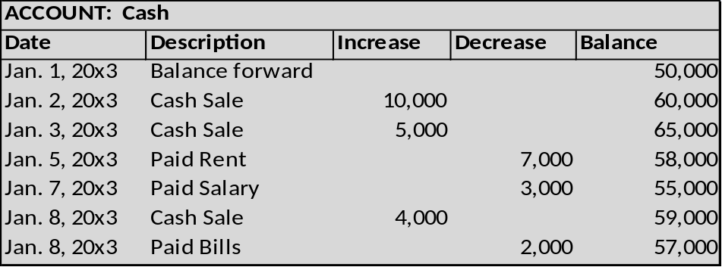
This account reveals that cash has a balance of $57,000 as of January 8. By examining the account, you can see the various transactions that caused increases and decreases to the $50,000 beginning of month cash balance. If you were to prepare a balance sheet on January 8, you would include cash for the indicated amount (and, so forth for each of the other accounts comprising the entire financial statements).

3.1.2 Debits and Credits
Without a doubt, you have heard or seen a reference to debits and credits; perhaps you have had someone "credit" your account or maybe you have used a "debit" card to buy something. Debits (sometimes abbreviated "dr") and credits (sometimes abbreviated "cr") are unique accounting tools to describe the change in a particular account that is necessitated by a transaction. In other words, instead of saying that cash is "increased" or "decreased," we instead say that cash is "debited" or "credited." This method is again traced to Pacioli, the Franciscan monk who is given credit for the development of our enduring accounting model. Why add this complexity - why not just use plus and minus? You will soon discover that there is an ingenious answer to this question! Understanding the answer to this question begins by taking note of two very important rules:
(1) Every transaction can be described in debit/credit form
And
(2) For every transaction, debits = credits. This is called “double entry”

The Fallacy of "+/-" Nomenclature
If for example taxes are received, both cash and revenues would increase (a "+/+" outcome). On the other hand, paying an account payable causes a decrease in cash and a decrease in accounts payable (a "-/-" outcome). Finally, some transactions are a mixture of increase/decrease effects; using cash to buy land causes cash to decrease and land to increase (a "-/+" outcome), that is one asset increases as another asset decreases.
As you can see, the "+/-" system lacks internal consistency. Therefore, it is easy to get something wrong and be completely unaware that something has gone amiss. On the other hand, the debit/credit system has internal consistency. If one attempts to describe the effects of a transaction in debit/credit form, it will be readily apparent that something is wrong when debits do not equal credits. Even modern computerized systems will preclude any attempt to enter an "unbalanced" transaction that does not satisfy the condition of debits = credits.

The Debit/Credit Rules

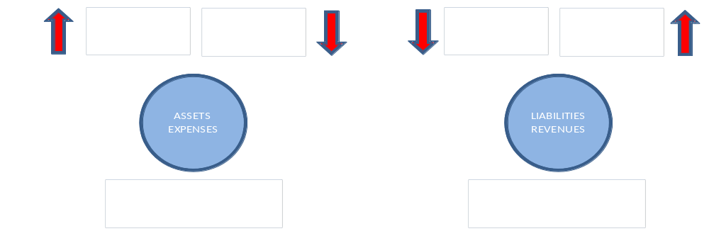

At first, it is natural for the debit/credit rules to seem confusing. However, the debit/credit rules are inherently logical. But, memorization usually precedes comprehension. So, you are well advised to memorize the "debit/credit" rules now -- even though these rules will not yet seem entirely logical. If you will thoroughly memorize these rules first, your life will be much easier as you press forward with your understanding of accounting.

Assets/Expenses
As shown above, these two types of accounts follow the same set of debit/credit rules. Debits increase these accounts and credits decrease these accounts. These accounts normally carry a debit balance.

Liabilities/Revenues
These two types of accounts follow rules that are the opposite of those just described. Credits increase liabilities, revenues, and equity (Surplus/Deficit for government), while debits result in decreases. These accounts normally carry a credit balance.

Analysis of Transactions and Events
You now know that transactions and events can be expressed in "debit/credit" terminology. In essence, accountants have their own unique shorthand to portray the financial statement consequence for every recordable event. This means that as transactions occur, it is necessary to perform an analysis to determine (a) what accounts are impacted and (b) how they are impacted (increased or decreased). Then, debits and credits are applied to the accounts, utilizing the rules set forth in the preceding paragraphs.
Usually, a recordable transaction will be evidenced by some "source document" that supports the underlying transaction:
A cash disbursement will be supported by the issuance of a check.
A sale might be supported by an invoice issued to a customer.
Receipts may be retained to show the reason for a particular expenditure.
A time report may support payroll costs.
A tax statement may document the amount paid for taxes.
A cash register tape may show cash sales.
Suffice it to say, there are many potential source documents, and this is just a small sample. Source documents usually serve as the trigger for initiating the recording of a transaction. The source documents are analyzed to determine the nature of a transaction and what accounts are impacted. Source documents should be retained (perhaps in electronic form) as an important part of the records supporting the various debits and credits that are entered into the accounting records. (See also section 2.3, Accounting Records).
A properly designed accounting system will have controls to ensure all transactions are fully captured. It would not do for transactions to slip through the cracks and go unrecorded. There are many such safeguards that can be put in place, including use of pre-numbered documents and regular reconciliations. For example, you possibly maintain a personal checkbook where you record your cash disbursements. Hopefully, you keep up with all of the checks (by check number) and perform a monthly reconciliation to ensure your checkbook accounting system has correctly reflected all of your disbursements. An organization/government must engage in similar activities to ensure all transactions and events are recorded correctly. Good controls are essential to accurate and timely recording.

Determining an Account’s Balance
The balance of a specific account can be determined by considering its beginning (of period) balance, and then netting or offsetting all of the additional debits and credits to that account during the period. Earlier, an illustration for a Cash account was presented. That illustration was developed before you were introduced to debits and credits. Now, you know that accounts are more likely maintained by using the debit/credit system. So, the Cash account is repeated below, except that the increase/decrease columns have been replaced with the more traditional debit/credit column headings. A typical Cash account would look similar to this illustration:
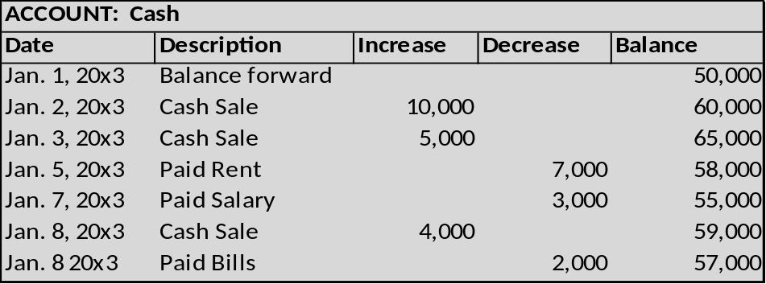

Common Misunderstanding about Credits
Some people wrongly assume that credits always reduce an account balance. However, a quick review of the debit/credit rules reveals that this is not true. Where does this notion come from? Probably because of the common phrase "we will credit your account." This wording is often used when you return goods purchased on credit; but, carefully consider that your account (with the store) is on the store's books as an asset account (specifically, an account receivable from you). Thus, the store is reducing its accounts receivable asset account (with a credit) when it agrees to "credit your account."
On the other hand, some may assume that a credit always increases an account. This incorrect notion may originate with common banking terminology. Assume that you made a deposit in your checking account at your Bank. Your bank balance sheet would include an obligation ("liability") to you for the amount of money on deposit. This liability would be credited (increased) each time you add to your account. Thus, you would be told that your account is being "credited" when you make a deposit.

3.2 Journals
Most everyone is intimidated by new concepts and terminology (like debits, credits, journals, etc.). But, learning can be made quite simple by relating new concepts to preexisting notions that are already well understood. So what do you know about a journal (not an accounting journal, just any journal)? It's just a log book. A place where you can record a history of transactions and events - usually in date (chronological) order.
An accounting journal is just a log book that contains a chronological listing of an organization’s transactions and events (each recorded event is known as a “Journal Entry”). However, rather than including a detailed narrative description of the organization’s transactions and events, the journal lists the items by a "form of shorthand notation." Specifically, the notation indicates the accounts involved, and whether each is debited or credited. The system must be sufficient to support the preparation of the financial statements, and be capable of maintaining retrievable documentation for each and every transaction. In other words, some transaction logging process must be in place. The journal satisfies the need for this logging process.
The general journal is sometimes called the book of original entry. This means that source documents are reviewed and interpreted as to the accounts involved. Then, they are documented in the journal via their debit/credit format. As such the general journal becomes a log book of the recordable transactions and events. The journal is not sufficient, by itself, to prepare financial statements. That objective is fulfilled by subsequent steps. But, maintaining the journal is the point of beginning toward that end objective.

3.2.1 Illustrating the Accounting Journal
The following illustration shows the journalizing process for a typical Organization’s transactions. You should review it carefully, specifically noting that it is in chronological order with each transaction of the organization being reduced to the short-hand description of its debit/credit effects. You will also note that each transaction is followed by a brief narrative description; this is a good practice to provide further documentation, but it is generally regarded as optional. For each transaction, it is customary to list "debits" first (left justified), then the credits (right justified).
As you review the general journal, note that it is only two pages long. An actual journal for an organization might consume hundreds and thousands of pages to document its many transactions. As a result, organizations generally maintain the journal in electronic form only – the Ministry of Finance, Government of Libya, will initially use BISAN.

General Journal
Date |  |  |  |  |  |  |  |  | Debits |  | Credits
1-1-X3 | Cash |  |  |  |  |  |  |  | 25,000
 |  |  | Customs Revenue |  |  |  |  |  |  |  | 25,000
 | Cash received from import duties
1-4-X3 | Advertising Expense |  |  |  |  |  |  |  | 2,000
 |  |  | Cash |  |  |  |  |  |  |  | 2,000
 | Paid advertising expense for initial awareness program
1-8-X3 | Cash |  |  |  |  |  |  |  | 4,000
 |  |  | Tax Revenue |  |  |  |  |  |  |  | 4,000
 | Received tax revenues
1-15-X3 | Rent Expense |  |  |  |  |  |  |  | 1,000
 |  |  | Cash |  |  |  |  |  |  |  | 1,000
 | Paid month rental on building
1-17-X3 | Cash |  |  |  |  |  |  |  | 8,000
 |  |  | Tax Revenue |  |  |  |  |  |  |  | 8,000
 | Received tax revenues
1-18-X3 | Telephone Expense |  |  |  |  |  |  |  | 500
 |  |  | Cash |  |  |  |  |  |  |  | 500
 | Paid monthly telephone expenses
General Journal |  |  |  |  |  |  |  |  |  | Page 2
Date |  |  |  |  |  |  |  |  |  | Debits |  | Credits
1-25-X3 |  | Cash |  |  |  |  |  |  |  | 20,000
 |  |  |  | Customs Revenue |  |  |  |  |  |  |  | 20,000
 |  | Received cash for import duties
1-28-X3 |  | Vehicles |  |  |  |  |  |  |  | 15,000
 |  |  |  | Cash |  |  |  |  |  |  |  | 15,000
 |  | Purchased used truck for cash
Now that you have reviewed the journal entries for January, consider the following.

3.2.2 Special Journals
First, the illustrated journal was referred to as a "general" journal. All transactions and events can be recorded in the general journal. However, an organization may sometimes use "special journals." Special journals are totally optional; they are typically employed when there are many similar type transactions. Thus, an organization could have special journals for each of the following: cash receipts, cash payments, sales, purchases, and/or payroll. These special journals do not replace the general journal. Instead, they just strip out recurring type transactions and place them in their own separate journal. Without special journals, you can well imagine how voluminous a general journal could become. But, for learning purposes, let's just rely on the general journal to accomplish our goals.

What are the Account Balances?
The general journal is a great tool to capture transaction and event details, but it certainly does nothing to tell an organization about the balance in each specific account. For instance, how much cash does the exhibited organization above have at the end of January? One could go through the journal and net the debits and credits to Cash ($25,000 - $2,000 + $4,000 -$1,000 + 8,000 - $500 + $20,000 - $15,000 = $38,500). But, this is tedious and highly susceptible to error. It would become virtually impossible if the journal were hundreds of pages long. A better way is needed. This is where the general ledger comes into play.

3.3 The General Ledger

3.3.1 The Ledger Concept
As you just saw, the general journal is, in essence, a notebook that contains page after page of detailed accounting transactions recorded in date sequence. In contrast, the general ledger is, in essence, another notebook that contains a page for each and every account in use by an organization. The ledger account for the sample organization would include the Cash page as illustrated below.
ACCOUNT: | Cash
Date | Description | Debit | Credit | Balance
Jan. 1, 20X3 | Balance forward |  |  | -
Jan. 1, 20X3 | Journal Page 1 | 25,000 |  | 25,000
Jan. 4, 20X3 | Journal Page 1 |  | 2,000 | 23,000
Jan. 8, 20X3 | Journal Page 1 | 4,000 |  | 27,000
Jan. 15, 20X3 | Journal Page 1 |  | 1,000 | 26,000
Jan. 17, 20X3 | Journal Page 1 | 8,000 |  | 34,000
Jan. 18, 20X3 | Journal Page 1 |  | 500 | 33,500
Jan. 1, 20X3 | Journal Page 2 | 20,000 |  | 53,500
Jan. 1, 20X3 | Journal Page 2 |  | 15,000 | 38,500
The above transactions utilized the following accounts:
Cash
Customs Revenue
Advertising Expense
Tax Revenue
Rent Expense
Telephone Expense
Land
Therefore, the general ledger will include a separate page for each of these nine accounts.

3.3.2 Posting
Before going into the details of each account, let's consider what we are about to do. We are going to determine the balance of each specific account by posting transactions to the account. To do this, we will post the entries listed in the journal into their respective ledger account. In other words, the debits and credits in the journal will be accumulated ("transferred"/"sorted") into the appropriate debit and credit columns of each ledger page. Here is an illustration of postings to the Cash account of the journal entries related to customs revenue. A similar process would occur for each of the other accounts:
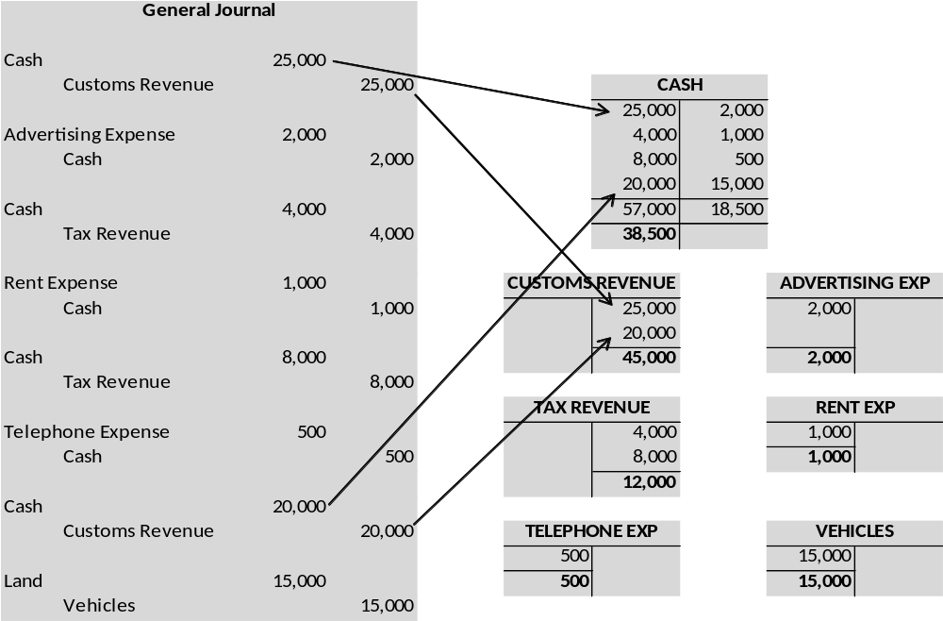
Shown below are all the ledger pages that our sample organization would reflect after posting all of the journal entries:
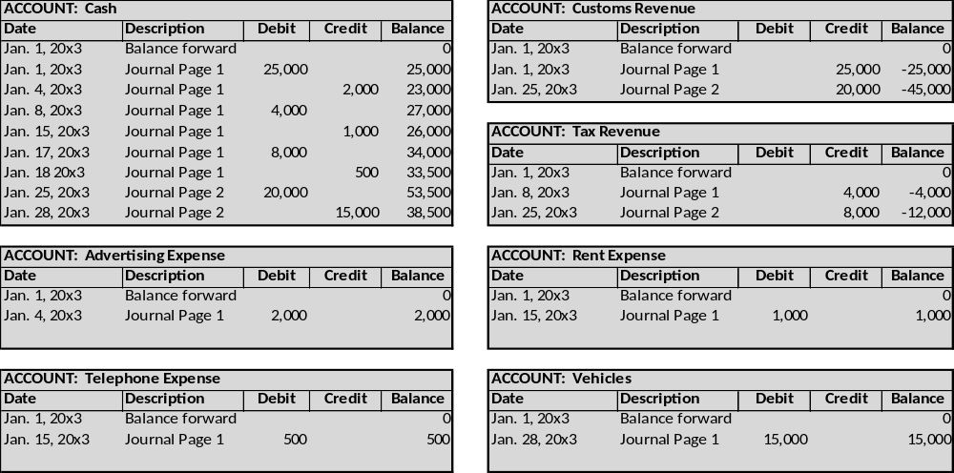
To Review: Thus far you should have grasped the following accounting "steps":
STEP 1: Each transaction is analyzed to determine the accounts involved
STEP 2: A journal entry is entered into the general journal for each transaction
STEP 3: Periodically, the journal entries are posted to the appropriate general ledger pages

3.4 The Trial Balance
After all transactions have been posted from the journal to the ledger, it is a good practice to prepare a trial balance. A trial balance is simply a listing of the ledger accounts along with their respective debit or credit balances. The trial balance is not a formal financial statement, but rather a self-check to determine that debits equal credits. Below is the trial balance prepared from our sample organization.
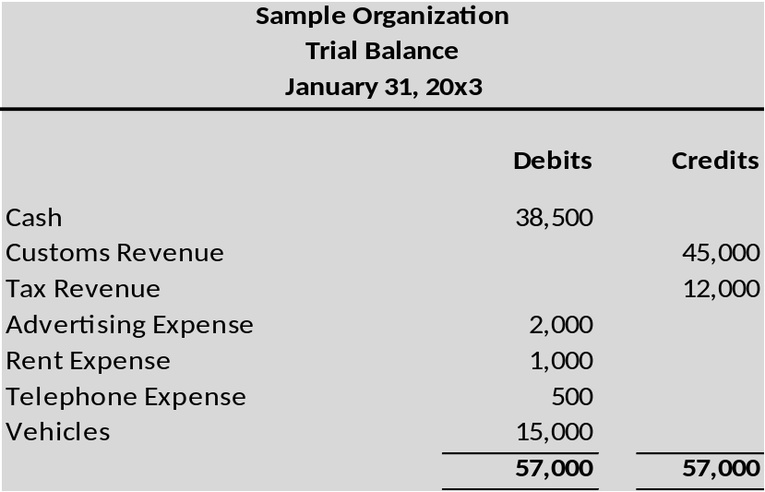

Debits Equal Credits
Since each transaction was journalized in a way that insured that debits equaled credits, one would expect that this equality would be maintained throughout the ledger and trial balance. If the trial balance fails to balance, an error has occurred and must be located. It is much better to be careful as you go, rather than having to go back and locate an error after the fact. You should also be aware that a "balanced" trial balance is no guarantee of correctness. For example, failing to record a transaction, recording the same transaction twice, or posting an amount to the wrong account would produce a balanced (but incorrect) trial balance.

Correcting and Reversing Entries
In the event that analysis of the trial balance shows the posting to an incorrect account, a correcting journal entry (JV) is required. If an entry has been posted twice in error then a reversing entry will be required to reverse one of the entries, leaving only the original entry on the books of account.

Financial Statements from the Trial Balance
Additional adjustments are usually needed to prepare a truly correct and up-to-date set of financial statements. However, at this point, a tentative set of financial statements can now be prepared based on the trial balance. The basic process is to transfer amounts from the general ledger to the trial balance, then into the financial statements.
In reviewing the following financial statements for our sample organization, notice that the items are taken directly from the trial balance above. The other line items and amounts simply relate to totals and derived amounts within the statements. These statements would appear as follows:
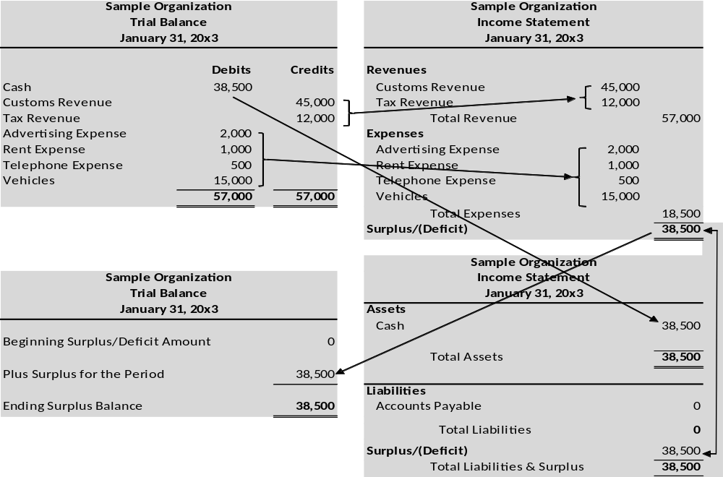
Notes:
- Revenue balances may be grouped or shown separately.
- Expense balances may be grouped or shown separately.
- The Surplus/Deficit is derived from subtracting all expenses from revenues. In this case there is a net surplus of 38,500.
- The surplus or deficit amount is entered into the Surplus/Deficit section of the Balance Sheet and the Statement of Surplus and Deficit.

3.4.1 T-Accounts
The following is an explanation of a useful tool known as the T-Accounts. T-Accounts are used for demonstrating certain transactions and events. One would not use t-accounts for actually maintaining the accounts; however they are used as a quick and simple way to figure out how a small number of transactions and events will impact an organization. In essence, T-accounts are just a "scratch pad" for account analysis. The physical shape of the T-account is a "T," with debits on the left side and credits on the right of the T. The "balance" is the amount by which debits exceed credits (or vice versa). Below is the T-account for Cash for the transactions and events of our sample organization. Carefully compare this T-account to the actual running balance ledger account which is also shown (notice that the debits (left side) total to $57,000, the credits (right side) total to $18,500, and the excess of debits over credits is $38,500 -- which is the resulting account balance).
T-accounts are often used by accountants to quickly analyze the impact of various transactions on an account or series of accounts. Regardless of how complex a set of transactions are, they can always be analyzed by using T-accounts.
T-Account for Cash
ACCOUNT: | Cash
Date | Description | Debit | Credit | Balance
Jan. 1, 20X3 | Balance forward |  |  | -
Jan. 1, 20X3 | Journal Page 1 | 25,000 |  | 25,000
Jan. 4, 20X3 | Journal Page 1 |  | 2,000 | 23,000
Jan. 8, 20X3 | Journal Page 1 | 4,000 |  | 27,000
Jan. 15, 20X3 | Journal Page 1 |  | 1,000 | 26,000
an. 17, 20X3 | Journal Page 1 | 8,000 |  | 34,000
Jan. 18, 20X3 | Journal Page 1 |  | 500 | 33,500
Jan. 25, 20X3 | Journal Page 2 | 20,000 |  | 53,500
Jan. 28, 20X3 | Journal Page 2 |  | 15,000 | 38,500
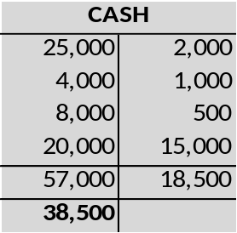

Comprehensive T-Account Illustration:
The following diagram illustrates the flow of transactions from the general journal to a set of T-accounts. To show all the links would be too “busy”, however you can see the links for the transactions that affect the Customs Revenue account and the Cash account.. You can easily follow all of the other accounts from the general journal to the T-Accounts. The debits/credits for each entry can be traced to the corresponding accounts. Once all of entries are transferred, the resulting balances for each account can be carried forward to form the trial balance.
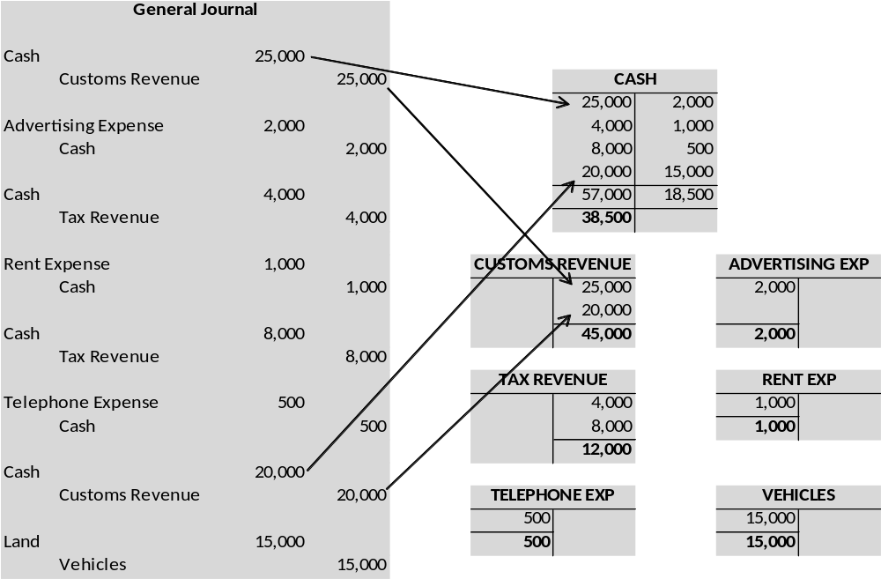

3.5 Financial Statements Reporting
General purpose financial reporting focuses on providing information to meet the common information needs of users who are unable to command the preparation of reports tailored to their particular information needs. These users must rely on the information communicated to them by the reporting entity.

3.5.1 Consolidated Financial Statements
. This section describes the financial statements in general terms to link to the accounting concepts described in this volume.
The Government of Libya can produce a number of different statements satisfying varying requirements for financial information; however there are two main financial statements in Cash-based reporting. They are: (1) Statement of Cash Receipts and Payments; (2) Statement of Comparison of Budget to Actual. In addition to the two mandatory statements, the Government can l disclose in the form of notes to the financial statements, (1) Statement of Changes from Original to Final Budget amount and notes to the financial statements.

3.5.2 Statement of Cash Receipts and Payments
TO BE COMPLETED

3.5.3 Statement of Comparison of Budget to Actual
TO BE COMPLETED

3.6 Chart of Accounts
A chart of accounts is a listing of the names of the accounts that an Organization has identified and made available for recording transactions in its general ledger.

3.6.1 What Should the Chart of Accounts Include?
The chart of accounts, which is a list of each account that the accounting system tracks, should be designed to capture the financial information you need to construct meaningful reports consistent with the selected accounting basis, cash or accrual, and to make good financial decisions. Only information recorded with an account code from the chart of accounts will be recorded into the financial records, and from there into financial reports.
The chart is divided into five categories: assets, liabilities, net assets or fund balances, revenues, and expenses. (Keep in mind that the Government of Libya operates on the cash basis and therefore liabilities are of limited interest as expenses are recognized when paid, not when incurred). Each account is assigned an identifying number for use within the accounting system. Aside from certain conventions regarding numbering and the order in which information is presented (see below), you can tailor your chart of accounts to your organization’s specific needs. In order to decide what to include in your chart of accounts you will want to consider each of the following questions:
What reports do you want to prepare?
What financial decisions, evaluations and assessments do you need to make on a regular basis?
What level of detail do you require?
What is your capacity for tracking financial information?
The best way to design a chart of accounts is to first consider what reports you want to prepare to satisfy international financial reporting requirements (IPSAS), donor requirements (GFS2001 and COFOG) and help you with internal management assessment and decision-making. You can then determine which categories to include in the reports you plan to produce. For example, your chart of accounts should correlate to the categories in your budget so you can easily prepare reports comparing budgeted with actual income and expenses.
As you think about the different types of income your organization receives, you might want to consider what questions you will want to address in your financial reports: Will you need to distinguish between grants and contributions for example? Do you earn fees for some of your services? If so, can all fees be combined into one account, or do you want information on fees from each type of activity?
You can ask yourself similar questions regarding your organization’s expenses: What is the lowest level of detailed information that you would like from your financial records? How will you use the information if you record it? For example, most organizations want to keep track of office supplies in the aggregate rather than accounting separately for paper clips, pens, rubber bands, etc. A less obvious example might be in postage. Do you want to include in the postage expense category fees for messengers and express delivery, or do you want to report these separately? If you are worried about the amount being spent on express delivery you should create a separate expense category. If you do not plan to analyze this level of detail, however, it would be advisable to combine the two categories. You can always interrogate specific invoices related to express delivery to do a periodic analysis without tracking the information in your general ledger.
In addition to the types of income and expenses you want to keep track of there may be other factors to consider as you put together the chart of accounts. If you have more than one site, do you want to keep track of information separately for each site? Or, if you have more than one program, do you want to keep track of items such as supplies, postage, salaries, etc. for each program?
The greater the level of detail you require, the greater the likelihood that you will need accounting software to keep track of your financial transactions. Accounting software often allows you to divide transactions into many small pieces, and then determine what level of detail to use in your reports. Keeping track of very detailed information manually is time consuming.
Of equal importance is the ability and availability of your accountant to manage a complex number of variables. For example, your accountant may need training to be able to support a more complex chart of accounts as your accounting systems becomes more complex.
A good rule of thumb is to keep the chart of accounts as simple as possible, and revise it as your need for information increases over time. Throughout the year, as you expend funds or receive money, keep track of those times when it was unclear to you which account number to assign to the transaction. That can be an indicator that the chart of accounts needs to be revised or that the criteria for assigning account numbers need to be clarified.

3.6.2 Features of a Simple Chart of Accounts
The sample chart of accounts provided at the end of this section illustrates how you might track income and expense items, along with conventions which are usually observed when assigning account numbers. This sample is intended to be a guide which you can use if you need to develop a chart of accounts from the basic concepts. It is not comprehensive and some of the accounts included in the sample may not be useful to you. You should note the following features of the sample chart of accounts:
Account categories are presented in a standard order, beginning with the accounts presented in the Statement of Position (Balance Sheet.) These are:

Assets
Assets are the tangible items an organization has as resources, including cash, accounts receivable (accrual based only), equipment and property. Assets are usually listed in descending order of liquidity. This means that cash and other assets which are easily converted to cash are listed first, and fixed assets such as property and equipment are listed last. Asset accounts typically start with the number "1."

Liabilities
Liabilities are obligations due to creditors, such as loans and accounts payable. Current liabilities, those obligations which fall due within the next year, are usually listed first, followed by long-term liabilities. Accounts payable and payroll taxes payable are usually listed before other payables. Unearned revenue and other liabilities are often further down on the list. Liabilities often begin with the number "2." Note: The PNA operates on a cash basis and therefore liabilities are of limited interest as expenses are recognized when paid, not when incurred.

Net Assets (Surplus/Deficit)
Net assets or Surplus/Deficit; reflect the financial worth of the organization. They represent the balance remaining after obligations are subtracted from an organization’s assets. Net asset accounts usually begin with the number "3."

Income and Expense accounts follow the Statement of Position Accounts
You will notice that account numbers proceed from lowest to highest, with room between numbers in each category. This allows you to expand the level of detail presented in the chart of accounts as your activities grow.
Certain related accounts are grouped together with related numbers. For example, the general number for Bonuses and Allowances is 2102. However, each type of bonus and allowance expense has been assigned its own account number Housing allowance is 210201, Assignment allowance is 210203, etc. Some computerized accounting software will allow you to prepare reports which aggregate all accounts with the code 21x into a single line item. Even manually, this type of expense grouping simplifies consolidating information for reports. Please note, however, that typically you would not post information to account 2102. This account is considered the "heading" for all related expenses.

3.6.3 Capturing More Complex Financial Information
If you need to keep track of separate funds, separate programs or departments, separate sites, etc., your chart of accounts can be designed to accommodate these needs using a "multi-segment" chart of accounts. The sample chart of accounts shows a single segment. Adding a second segment or block to your account codes allows you to code line items into various categories.
For example, suppose an organization has three programs: counseling, tutorial, and recreation. Each program would receive its own account code as follows:
Counseling | 01
Tutorial | 02
Recreation | 03
Adding these to the codes for natural expense items found in the sample chart of accounts, you would now attribute salaries for counselors as follows:

210101 | - 01
Salaries | Counseling program
Other Equipment for the recreational program would be posted to:
221304 | - 03
Other Equipment | Recreation program
You can even keep track of both programs and sites by adding a third block. For example, if you have a tutorial program at each of two schools, you might assign the first school the letter "A" and the second the letter "B." So, salaries for tutors would be divided between 210101 - 02 – A and 210101 - 02 – B:
210101 | - 02 | - B
Salaries | Tutorial program | School B
As the chart of accounts becomes more complex, it can enable you to produce reports which are more and more detailed. Again, however, doing so depends on the time and ability of the financial staff and the sophistication of your financial systems since multi-segment accounting is difficult to maintain without a computer (the PNA’s FMIS system maintains a complex chart of accounts with multiple segments).

Sample Chart of Accounts
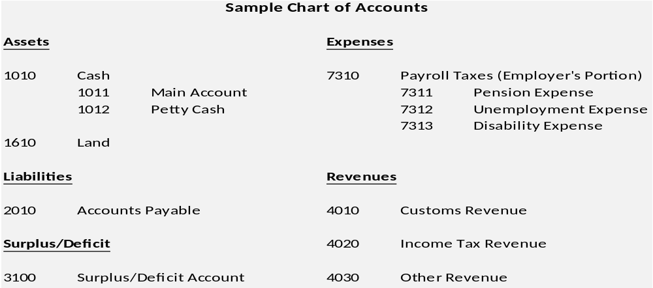
This partial sample has been developed using some of the broad account headings and codes. This example illustrates the way in which the Chart of Accounts can be tailored to the specific needs of an individual organization.

3.7 Subsidiary ledger and registers
Some accounts in the General Ledger require additional information that the General Ledger does not supply. An example is an individual employee’s travel expense account. From time to time employees are given advances to travel. Checks or bank transfers given to employees for this purpose are charged to the Travel Advance account in the General Ledger. At the end of each accounting period the total of all Travel Advances are charged to Travel Advance account. This account is known as the control account. In order to keep track of individual employee charges to the control account, a subsidiary ledger is maintained for each employee that has received a Travel Advance. The sum total of all the individual employee subsidiary accounts must agree with the Travel Advance account in the General Ledger.
It is imperative that an organization be able to reconcile subsidiary accounts to the broader control account that is found in the general ledger. An example is shown below:
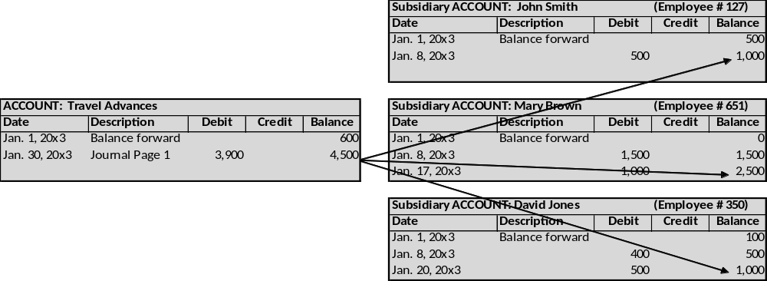

3.8 Petty Cash
The purpose of a Petty cash fund is to allow for small purchases or reimbursements, in cash. It is used for items such as stamps, office supplies, parking, etc. Senior management must develop a policy of how much money should be available in cash, and a maximum expenditure which can be paid with petty cash. The fund should be enough to cover petty cash expenditures for about a month. If it is too small you will have to constantly replenish the funds, and if it is too large it means you have cash on hand which could be more safely kept in your bank account.
The petty cash fund should be kept in a locked box or drawer. Auditors recommend that only one person, called the custodian, have access to this cash, and that person be responsible for all petty cash activity. To disburse petty cash funds, the organization will need to buy or develop petty cash vouchers for documenting each transaction, and determine who in the organization can approve petty cash payments. In some cases, this will be the director; in others, petty cash may also be approved by department heads or the petty cash custodian, within guidelines established by the board.

3.8.1 Establishing a Petty Cash Fund
Once management has determined (with staff input) how large a fund is needed, a check is written to the petty cash custodian (not to cash) to establish the petty cash fund.
To reimburse someone for a small purchase proof of purchase should be obtained, usually a receipt from the store, post office, etc. A petty cash voucher, detailing the nature and reason for the purchase is then prepared, approved by the petty cash custodian and the original purchaser reimbursed.
In some cases, the organization may permit an advance from petty cash to cover an upcoming purchase. In this case, the officer completes a voucher for the advance, approved by the custodian. When the officer returns he or she completes an accurate voucher for the final amount, attaches the receipt, and returns any change to the custodian.

3.8.2 Replenishing the Petty Cash Fund
Once the fund is substantially depleted, the petty cash custodian adds up the vouchers and assigns them into appropriate categories (e.g., postage, printing and copying, office supplies, etc.) The total of receipts plus cash available must equal the original advance in order to prove that all money has been accounted for. When the account has been balanced, a check is written (in accordance with the check authorization procedure established for all disbursements,) again payable to the petty cash custodian, for the exact amount of the vouchers/receipts, bringing the fund back to its original balance.
This method of maintaining a constant amount in petty cash through a combination of cash and receipts is called an imprest system. The petty cash vouchers should be stapled to the summary of expenses prepared and filed away so they are not reimbursed a second time.
When entering the reimbursement transaction into the accounting system you increase (debit) expenses, and decrease (credit) cash:
Notice that you do not post the expenses to an account called petty cash. This way, at the end of the year, you have a true picture of your expenses, which is more helpful for future planning than a lump sum in a petty cash line.

3.8.3 Petty Cash Internal Controls Checklist
The following questions reflect common internal accounting controls related to petty cash.
Is an imprest petty cash fund maintained for payment of small, incidental expenses?
Is there a limit to the amount that can be reimbursed by the petty cash fund?
Is supporting documentation required for all petty cash disbursements?
Is a petty cash voucher filled out with supporting documentation, name of person being reimbursed and proper authorization?
Is access to petty cash limited to one person who is the fund custodian?
Are unannounced counts of petty cash made by someone within the agency other than the fund custodian?

3.9 Bank Reconciliations
A Bank Reconciliation is a test of how accurate your cash book is compared to the bank statements. This will include checking that all checks/payment orders have been entered correctly into the cash book and that all bank charges, interest and direct debits have been recorded.
The bank balance per the cash book is unlikely to agree to the balance on the bank statement at the same date, due to payments by check taking a few days to be presented and cleared at the bank, and deposits not being cleared. The bank reconciliation shows how the difference can be explained.
The reconciliation should be performed at least monthly, to ensure that any errors are corrected as soon as possible. For the main Treasury accounts particularly the Revenue accounts like the daily reconciliations follows best practice.
See Procedures Manual Module 7.2 for detailed discussion of how bank reconciliations are performed by the Ministry of Finance using the BISAN MIS.

Cash Book Differences
There may be items that appear on the bank statement that are not in the cash book, such as bank interest, bank charges, or direct debits. This will usually be because they are not known about until the bank statement is received.
The cash book therefore needs to be adjusted by adding these items.
It will also need to be adjusted where there are errors, such as the amount recorded in the cash book being different to that on the bank statement. If, however, this is due to a bank error, the bank should be contacted, rather than amending the cash book.

Timing Differences
Most of the differences between the bank statement and the cash book balances will be due to timing differences.
These may be check payments that have not yet cleared the bank and do not therefore appear on the statement. These are known as unpresented checks. Amounts paid into the bank that have not cleared may also be part of the difference. These are known as uncleared deposits.
In these situations the bank balance is not current and must be adjusted to take these items into account. This is where a bank reconciliation will need to be prepared to show the true balance.

Completing a Bank Reconciliation – Simple Theory
To carry out a bank reconciliation you:
- Start by comparing each payment that is in the cash book (Bisan) and also on the bank statement. Tick both the cash book and the bank statement. Then do the same for all bank income. Only tick entries which appear on the bank statement up to the last day of the month for which the reconciliation is being prepared, not after. [See Module X.XX to review how exactly this is technically performed in Bisan]
- Now look at the bank statement and identify any items that have not been ticked. Enter these items into the cash book, then tick them off on the bank statement.
- Every item that is on the bank statement is now in the cash book.
- Then add up all the columns in the cash book and calculate the bank balance at the end of the month.
- Now go through the cash book and make a list of any items that have not been ticked. These should all be unpresented checks or uncleared deposits.
- Finally, prepare the bank reconciliation. This should show the balance on the bank statement at the end of the month, less any unpresented checks, plus any uncleared deposits. The end balance should be equal to the cash book balance.
It is the balance at the end of the bank reconciliation and per the cash book that is the balance to be used in the year end accounts, rather than the balance shown on the actual bank statement. This is because it is the bank statement that is not current.

3.10 Government Assets
Since the Government of Libya operates on a cash basis of accounting, the purchase of all assets are expensed in the year of acquisition regardless of the economic or useful life of the asset. They are therefore treated in the same manner as any other expense. There are, however, additional requirements to maintain asset registers to track the assets and ensure safe keeping and maintenance.
A “Capital Asset” would include all tangible and intangible non-financial assets that are purchased, constructed, developed, or otherwise acquired (such as land, buildings, vehicles, machinery etc.) and: (a) have a useful life extending beyond one fiscal year and are intended to be used on a continuing basis; (b) have a financial value of $?????? or more; and (c) beneficial ownership and control clearly rests with the government.
“Capital Expenditures” are payments for the acquisition of fixed capital assets, strategic or emergency stocks, lands or intangible assets, or unrequited payments for purpose of permitting the recipients to acquire such assets, compensating the recipients for damage or destruction of capital assets, or increasing the financial capital of the recipients, and have a financial value above $??????.
“Non Capital Assets” are tangible or intangible assets having (a) an initial estimated useful life beyond a single year and (b) having an initial cost more than $????? and less than $?????.
When an asset is purchased, the Budget Organization (Ministry) is tasked with maintaining an Asset Register which shall include the following:
Asset name;
Name of Budget Organization (Ministry);
Responsible Person within Ministry;
Physical description;
Serial number;
Date of receipt;
Location;
Category;
Financing source;
Original or estimated value;
Date of disposal.
Expense voucher reference number (Payment Request Voucher # ).
The Budget Organization enters the asset information in the Asset Register. The Asset Register is a database owned by the Budget Organization used for asset maintenance. This should not be confused with the Accounting record which is the financial recording of the asset in the financial Accounting system.

Attachment 1 – Accounting Concepts

A. Fundamental Concepts

1. Economic Entity Assumption
The accountant keeps all of the business transactions of an organization separate from the business owner's personal transactions. For legal purposes, an organization and its owner are considered to be one entity, but for accounting purposes they are considered to be two separate entities. From a government point of view, all transactions of the government are recorded and reported upon, but not combined with its owners, the citizens of Libya.

2. Monetary Unit Assumption
Economic activity is measured in the base currency of Libyan Dinar (LYD), and only transactions that can be expressed in LYD are recorded. The Government performs transactions in many other currencies but the reporting or “base” currency is LYD. The annual budget is also prepared in LYD, the base currency in the accounting system.
Because of this basic accounting principle, it is assumed that the LYD’s purchasing power has not changed over time. As a result, accountants ignore the effect of inflation on recorded amounts. For example, LYD from a 2011 transaction are combined (or shown with) LYD from a 2013 transaction. The exception to the above is in the case of a hyper-inflation economy. In this environment it is necessary to restate the statement of cash receipts and payments and other financial statements in terms of the measuring unit current at the reporting date.

3. Time Period Assumption
This accounting principle assumes that it is possible to report the complex and ongoing activities of an organization in relatively short, distinct time intervals such as the five months ended May 31, 2012, or the 5 weeks ended May 1, 2013. The shorter the time interval, the more likely the need for the accountant to estimate amounts relevant to that period.
It is imperative that the time interval (or period of time) be shown in the heading of each income statement, statement of stockholders' equity, and statement of cash flows. For the Government of Libya, since it utilizes the Cash-Basis, this would mean that the Statement of Receipts and Payments and Budget Execution Statement are labeled appropriately with respect to the time interval. Labeling one of these financial statements with "December 31" is not good enough--the reader needs to know if the statement covers the one week ending December 31, 2008 the month ending December 31, 2012 the three months ending December 31, 2012 or the year ended December 31, 2012. This can also be shown as a “date from” and “date to”, for instance 1 January 2012 – 31 December 2012.

4. Cost Principle
From an accountant's point of view, the term "cost" refers to the amount spent (cash or the cash equivalent) when an item was originally obtained, whether that purchase happened last year or thirty years ago. For this reason, the amounts shown on financial statements are referred to as historical cost amounts.
Normally following acquisition of an asset, it will be carried under the accrual basis of accounting at its cost less any accumulated depreciation. An alternative to this method is to revalue the asset and carry the revalued amount less any accumulated depreciation.
As stated, the Government of Libya uses the cash basis of accounting and therefore accumulated depreciation and revaluation does not apply.

5. Full Disclosure Principle
If certain information is important to an investor or lender or any other user of the financial statements (citizens of Libya in the case of the government), then that information should be disclosed within the statement or in the notes to the statement. It is because of this basic accounting principle that numerous pages of "footnotes" are often attached to financial statements. In Cash-based IPSAS reporting, this often amounts to numerous “voluntary” disclosures being made in the notes to the financial statements.
As an example, let's say an organization is named in a lawsuit that may result in significant legal costs to conduct the law suit and/or expose the organization to costs if the law suit is lost. When the financial statements are prepared it is not clear whether the organization will be able to defend itself or whether it might lose the lawsuit. As a result of these conditions and because of the full disclosure principle, the lawsuit and its financial implications will be described in the notes to the financial statements, often referred to as contingent liabilities.
An organization usually lists its significant accounting policies as the first note to its financial statements. This is no different for the government accounts of the Government of Libya.

6. Going Concern Principle
This accounting principle assumes that an organization will continue to exist long enough to carry out its objectives and commitments and will not liquidate in the foreseeable future. If the organization's financial situation is such that the accountant believes the organization will not be able to continue, the accountant is required to disclose this assessment.
This principle applies equally to governments as it does to private entities.

7. Matching Principle
This accounting principle requires organizations to use the accrual basis of accounting. The matching principle requires that expenses be matched with revenues. For example, wages to employees are reported as an expense in the week when the employees worked and not in the week when the employees are paid. If a company agrees to give its employees 1% of its 2012 revenues as a bonus on January 15, 2013, the company should report the bonus as an expense in 2012 and the amount unpaid at December 31, 2012 as a liability. (The expense is occurring as the bonus is occurring.)
Because we cannot measure the future economic benefit of things such as advertisements (and thereby we cannot match the ad expense with related future revenues), the accountant charges the ad amount to expense in the period that the advertisement is running.
As stated, the Government of Libya uses the cash basis of accounting and therefore the matching principle does not apply.

8. Revenue Recognition Principle
Under the accrual basis of accounting (as opposed to the cash basis of accounting), revenues are recognized as soon as a product has been sold or a service has been performed, regardless of when the money is actually received. Under this basic accounting principle, an organization could earn and report $20,000 of revenue in its first month of operation but receive $0 in actual cash in that month
For example, if ABC Consulting completes its service at an agreed price of $1,000, ABC should recognize $1,000 of revenue as soon as its work is done--it does not matter whether the client pays the $1,000 immediately or in 30 days. Do not confuse revenue with a cash receipt in accrual accounting.
As stated, the Government of Libya uses the cash basis of accounting and therefore the revenue recognition principle does not apply. Revenue is only recorded when cash is physically received.

9. Materiality
Because of this basic accounting principle or guideline, an accountant might be allowed to violate another accounting principle if an amount is insignificant. Professional judgment is needed to decide whether an amount is insignificant or immaterial
An example of an obviously immaterial item is the purchase of a 150 dollar printer by a highly profitable multi-million dollar organization. Because the printer will be used for five years, the matching principle directs the accountant to expense the cost over the five-year period. The materiality guideline allows this organization to violate the matching principle and to expense the entire cost of 150 dollars in the year it is purchased. The justification is that no one would consider it misleading if 150 dollars is expensed in the first year instead of 30 dollars being expensed in each of the five years that it is used.
Because of materiality, financial statements usually show amounts rounded to the nearest Dinar (or another designated reporting currency), to the nearest thousand, or to the nearest million dollars, depending on the size of the organization.

10. Conservatism
If a situation arises where there are two acceptable alternatives for reporting an item, conservatism directs the accountant to choose the alternative that will result in less net income and/or less asset amount. Conservatism helps the accountant to "break a tie." It does not direct accountants to be conservative. Accountants are expected to be unbiased and objective.
The basic accounting principle of conservatism leads accountants to anticipate or disclose losses, but it does not allow a similar action for gains. For example, potential losses from lawsuits will be reported as contingent liabilities in the notes to the financial statements, but potential gains will not be reported. Also, an accountant may write inventory down to an amount that is lower than the original cost, but will not write inventory up to an amount higher than the original cost.

B. Basic Accounting Records
Cash Book - is the main book of entry. In many organizations, the cash book actually consists of two separate books, the Cash Disbursements Book (where all payments are recorded) and the Cash Receipts Book (where all deposits are recorded). These books, although not physical, are used in the same manner with the Government of Libya’s MIS, it is just electronic.
Cash Receipts Book – This is where all revenue and cash receipts are recorded.
Cash Disbursements Book – This is where all purchase & expense invoices/payments are recorded.
General Ledger – The General Ledger (GL) is the main book of accounts (ledger) that contains all of the financial accounts of an organization (including control accounts, e.g. cash account, accounts receivable and accounts payable). Once the Primary books of accounts are summed (usually on a monthly basis on a manual system but done continuously in an automated system), they are posted to the General Ledger. This is done via BISAN, however, the concept is exactly the same.
The General Journal – is a record of the adjustments made to the general ledger accounts. Adjustments are made using Journal Vouchers (JVs) and as mentioned above should only be used to adjust GL entries and not be used as the main source for making accounting entries.
Subsidiary Ledgers – Subsidiary ledgers general offer greater detail and balances are summarized in control accounts on the GL. There are specific accounts within the General Ledger for which additional information is required. The following subsidiary ledgers are just a few that may be found in any typical general ledger:
Travel Advances - This is a memorandum record that keeps track of all employees that owe money to the organization arising from travel advances given them for business related travel. The sum of this subsidiary ledger (employees) should equal the Travel Advance control account.
The following are other common subsidiary ledgers used. Note, these can be used regardless of the basis of accounting used, cash or accrual. The difference is the timing for when entries are made into the subsidiary ledgers:
Receivables Ledger – This is a memorandum record that keeps track of all entities that owe money to the Government of Libya. The sum of this subsidiary ledger (customers/contacts) should equal the accounts receivable control account. Budget Allotments paid to Spending Units are recorded in Bisan as a Receivable as it is treated as at advance of funds to the Spending Unit with the balance being “repaid” or reduced upon the acquittal of actual spending..
Payables Ledger – Generally only applicable in accrual based accounting, however not exclusively. The sum of this subsidiary ledger (vendors/contacts) should equal the accounts payable control account in the GL.
Financial Statements for Cash-Based Reporting in accordance with IPSAS include Statement of Receipts and Payments, Budget to Actual Comparison Statement and accompanying notes to the financial statements. In an accrual environment, the statements are Balance Sheet, Income Statements, Statement of Equity and notes to the financial statements.

C. Accounting Elements

1 Assets
The definition of Assets according to IPSAS:
Resources controlled by an entity as a result of past events and from which future economic benefits or service potential are expected to flow to the entity.
In other words, assets are economic resources of the organization that are expected to bring benefits for the organization in the future. Assets are divided into the following categories:
Fixed assets
Current assets
Other assets.

Fixed assets
Also referred to as PPE (property, plant, and equipment), or tangible assets, these are purchased for continued and long-term use in earning revenues in an organization. This group includes land, buildings, machinery, furniture, tools, and certain wasting resources e.g., timberland and minerals. They are written off against revenue over their anticipated life by charging depreciation expenses (with exception of land).
Accumulated depreciation is shown on the face of the balance sheet or in the notes. The Government of Libya does not apply depreciation as it follows the cash-basis of accounting.

Current assets
Current assets are cash and other assets expected to be converted to cash, sold, or consumed either in a year or in the operating cycle. These assets are continually turned over in the course of normal organizational activity. There are generally 5 categories of items included in current assets:
Cash – this is the most liquid current asset, which includes currency, deposit accounts, and negotiable instruments (e.g., money orders, checks, bank drafts).
Short-term investments – include securities bought and held for sale in the near future to generate income on short-term price differences (trading securities).
Receivables – receivables are usually reported as net of allowance for uncollectible accounts in an accrual system but allowances are not considered in a cash-based system.
Inventory – trading these assets is a normal activity of an Organization. The inventory value reported on the balance sheet is usually the historical cost or fair market value, whichever is lower. This is known as the “lower of cost or market” rule. For the Government of Libya, inventory would most likely be in the form of a central “stores” inventory.
Prepaid expenses – these are expenses paid in cash and recorded as assets before they are used or consumed (a common example is insurance which may be purchased for a full year or longer in advance).
Long-term investments - often referred to simply as “investments.” Long-term investments are to be held for many years and are not intended to be disposed in the near future.
This group usually consists of four types of investments:
Investments in securities, such as bonds, common stock, or long-term notes.
Investments in fixed assets not used in operations (e.g., land held for sale).
Investments in special funds (e.g., sinking funds or pension funds).
Investments in subsidiaries or affiliated Organizations.
Different forms of insurance may also be treated as long term investments.

Other assets
Other assets include a variety of assets, most commonly:
Long-term prepaid expenses;
Long-term receivables;
Intangible assets (for example goodwill); and
Property held for sale.

2 Liabilities
The definition of Liabilities according to IPSAS:
Present obligations of the entity arising from past events, the settlement of which is expected to result in an outflow from the entity of resources embodying economic benefits or service potential.
In financial accounting, a liability is defined as an obligation of an entity arising from past transactions or events, the settlement of which may result in the transfer or use of assets, provision of services or other yielding of economic benefits in the future.
Liabilities are classified into the following categories:
Current liabilities
Long-term liabilities
Other liabilities.

Current liabilities
These liabilities are reasonably expected to be liquidated within a year. They usually include payables such as wages, accounts, taxes, and accounts payables, unearned revenue, portions of long-term bonds to be paid this year, short-term obligations (e.g. from purchase of equipment), and others.

Long-term liabilities
These liabilities are reasonably expected not to be liquidated within a year. They usually include issued long-term bonds, loans, long-term leases, pension obligations, and long-term product warranties.

Other liabilities
Other liabilities include small and relatively insignificant liabilities. For financial reporting purposes, organizations often combine small liabilities into this single category rather than listing each liability separately.
Recorded on the accrual balance sheet, liabilities include loans, accounts payable, mortgages, deferred revenues and accrued expenses. The Government of Libya operates on the cash basis and therefore the term liability has much more restricted application, although liabilities do exist.

3 Surplus/Deficit (Equity)
The definition of equity according to IPSAS:
The residual interest in the assets of the entity after deducting all its liabilities.
In accounting, ownership is described by the term “equity”, thus equity is equal to assets minus liabilities. In other words, equity is the net worth of the organization after all liabilities has been paid off by the organization. Governments recognize the foregoing as Surplus or Deficit.

4 Revenues
The definition of revenues according to IPSAS:
The gross inflow of economic benefits or service potential during the reporting period when those inflows result in an increase in net assets/equity, other than increases relating to contributions from owners.
Revenues are all the money that an organization earned during the period. Net income is what is left after subtracting expenses.
When using the cash basis of accounting, receivables are not reported as sales and are only recognized when cash is received. Sales for cash basis accounting are all the cash sales for the period plus all cash taken in for sales from prior periods.
For the accrual basis of accounting, revenues are realized when assets received are readily convertible to known amounts of cash or claims to cash. Revenues are earned when the entity has performed its duties to be entitled to compensation.
There are many transactions of this kind:
- Revenues from customs duties collected.
- Revenue from taxes collected.
- Revenue from interest earned.
- Revenue from fines, licensees, fees, etc.
- Revenue from selling inventory is recognized at the date of sale (usually interpreted as the date of delivery).
- Revenue from performing services is recognized when services have been performed and are billable.
- Revenue from permission to use Organization’s assets (e.g. interests for using money, rent for using fixed assets, and royalties for using intangible assets) is recognized as time passes or as assets are used.
- Revenue from selling an asset other than inventory is recognized at the point of sale.

5 Expenses
The definition of expenses according to IPSAS:
Decreases in economic benefits or service potential during the reporting period in the form of outflows or consumption of assets or incurrence of liabilities that result in decreases in net assets/equity, other than those relating to distributions to owners.
In accounting terms, an expense is a general term for an outgoing payment for goods and services received by an organization or individual. Organization expenses are the costs of carrying on a business. The same concept applies for governments as well.
The following gives some examples of the types of cost, which are allowable as legitimate types of organization expense:
Salaries and wages;
goods and services;
capital expenditures;
subsidies;
rentals;
utilities, etc.
Organization expenditure is deducted in the accounts for the period in which it was incurred in accrual-based accounting, even if you are not due to pay the money until later. In cash-based accounting, only when the physical payment is made is when the expenditure is recorded into the accounts. The Government of Libya strictly follows cash based accounting for expenditures.

D. Illustration of Cash versus Accrual Basis of Accounting
The following example shows the results of a small organization that provides web design services to a number of clients and has been using the cash basis of accounting. The following spreadsheet is used by the sample organization to keep the business's cash receipts and payments. This type of spreadsheet is very common for a small business. The "checkbook" is in green noting the date, party, check number, check amount, deposit amount, and resulting cash balance. The deposits are allocated to the revenue column (shaded in tan) and the checks are allocated to the appropriate expense columns (shaded in yellow). Note that total cash on hand increased by $15,732.70 (from $7,911.12 to $23,643.82) during the month.
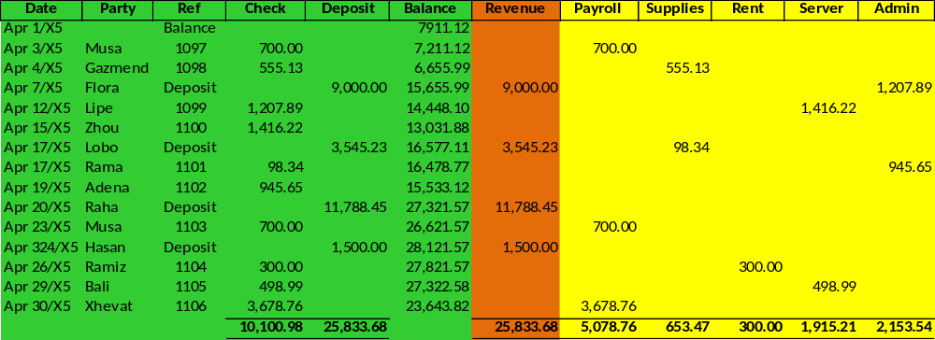The information from this spreadsheet was used to prepare the following "cash basis" income statement for December, 20X5. The increase in cash that is evident in the spreadsheet is mirrored as the "cash basis income":
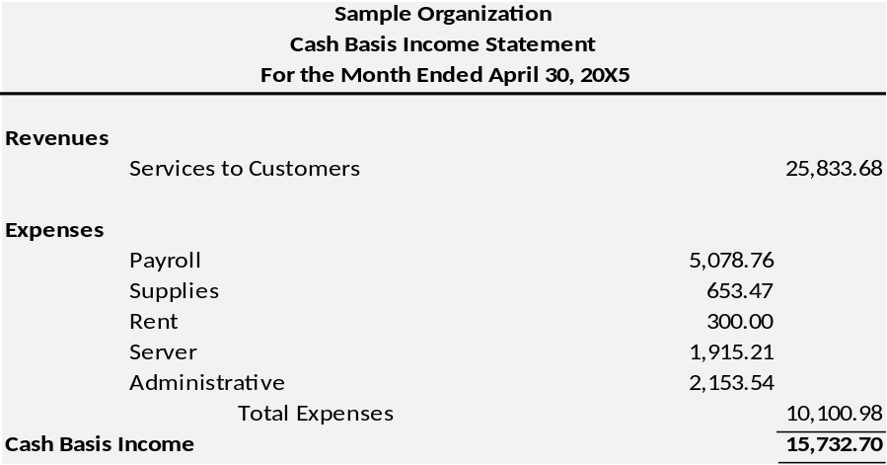
Our organization been approached by another company, a much larger web-hosting and design firm. They have offered to buy our business for a price equal to "100 times" the business's monthly net income, as determined under generally accepted accounting principles. An accounting firm has been retained to restate the April income statement under the accrual basis. The following additional information is gathered in the process of preparing the GAAP-based income statement:
Revenues:
- The $9,000 deposit on April 7 was an advance payment for work to be performed equally during April, May, and June.
- The $11,788.45 deposit on April 20 was collection of an account for which the work was performed during January and February.
- During April, services valued at $2,000 were performed and billed, but not yet collected.
Expenses:
- Payroll -- The $700 payment on April 3 related $650 to the prior month. An additional $350 is accrued by the end of April, but not paid.
- Supplies -- The amount paid corresponded to the amount used.
- Rent -- The amount paid corresponded to the amount used.
- Server -- The $1,416.22 payment on April 15 related $500 to prior month's usage.
- Admin -- An additional $$600 is accrued by the end of April, but not paid.
The accounting firm prepared the following accrual basis income statement and corresponding calculations in support of amounts found in the statement:
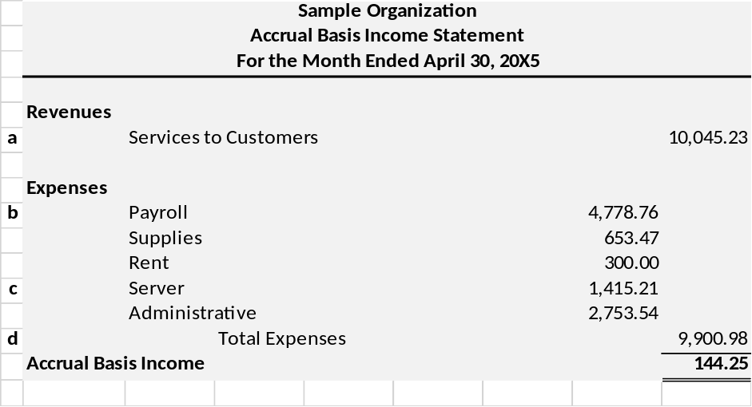
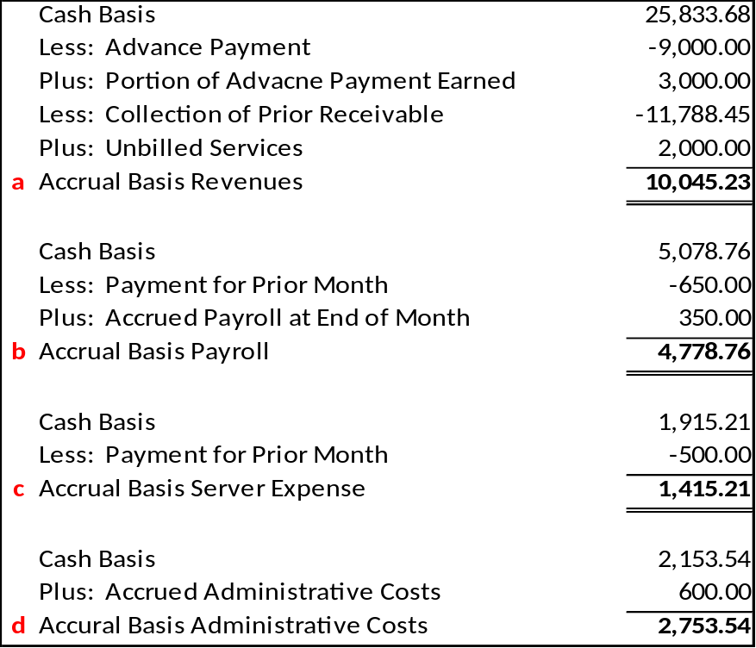
Although our organization was initially very interested in the offer, they were very disappointed with the resulting accrual-basis net income and decided to reject the deal. This illustration highlights the important differences between cash- and accrual-basis accounting. Cash basis statements are significantly influenced by the timing of receipts and payments, and can produce periodic statements that are not reflective of the actual economic activity of the business for the specific period in question. The accrual basis does a much better job of portraying the results of operations during each time period. This is why it is very important to grasp the revenue and expense recognition concepts discussed in this chapter, along with the related adjusting entries that may be needed at the end of each accounting period.

Government Financial Statistics
Classification of the Functions of Government

