Kosovo: Pension Policy Challenges in 2020

Executive Summary
Kosovo’s pension system started from scratch after its conflict with Serbia. It is based on a fully funded Defined Contribution (DC) scheme and a universal basic pension. However, the government has subsequently introduced a significant number of unfunded schemes and war-related benefits. These additional benefits are straining the costs of the system and threaten its sustainability, while introducing significant fragmentation and unclear incentives to participate in the contributory system.
The government should move toward building a unified pension system, consisting of multiple complementary pillars that are adequately financed in a sustainable manner in the long term. The system should provide adequate lifetime benefits and care as incentives to contribute. Institutional strengthening will be needed to manage the system and avoid excessive cost increases in the future.
- Main Indicators
The pension system in Kosovo comprises a universal basic pension financed by general revenue, a mandatory defined contributions system based on individual savings, a rarely used voluntary savings scheme, and a series of categorical and special benefits defined both for specific populations and related to the war.
Given its components, we can characterize the pension system in Kosovo as consisting of two parts: A ‘core’ multipillar scheme comprising the basic universal pension (Pillar 0), mandatory DC scheme (2nd pillar) and voluntary savings (3rd pillar) on one hand, and a series of categorical benefits on the other.
The main components of old-age benefits in the pension system are as follow:
- Basic Pension: Universal benefit to all citizens 65 years old or older residing in Kosovo.
- Mandatory savings: 10 percent contribution rate into individual accounts managed by an independent public entity (Kosovo Pensions Savings Trust, KPST). Provides monthly pension of €200 until account depletion (no lifetime pension).
- Ex-contributory benefit: Benefit for citizens 65 years or older who contributed at least 15 years in the former Yugoslav system. Benefit schedule in 4 tiers according to education (as proxy for income).
- Early retirement schemes: There are separate early retirement benefits with different rules that apply to Trepca miners, Kosovo Protection Corps (KPC), and Kosovo Security Force (KSF).
In addition, the government has introduced pension benefits for the permanently disabled, blind, paraplegic, and tetraplegic, as well as a series of permanent pension benefits to victims or participants in the war for independence.
Table 1: Pension Parameters in Kosovo
Retirement age | 65 years for men and women.
Pension calculation | From KPST: If balance < €3,000, lump sum  If €3,000 < balance < €20,000, pension is €200 per month until account depletion.  If balance > €20,000 pension is 1% of balance until account depletion.  Additionally, basic pension of €90 or ex-contributory benefit if qualified.
Indexation postretirement | None
Eligibility for disability pension | Declared disabled by Ministry of Labour and Social Welfare (MLSW). No minimum contribution.
Level of disability pension | From KPST: Full account withdrawal  From MLSW: €90 for permanently disabled
Eligibility for survivor’s pension | From KPST: Death before pension withdrawals, legal beneficiaries inherit balance.
Level of survivor’s pension | Full balance paid in lump sum.
Contribution rates | 10% of gross salary—5% by employer and 5% by employee.
Given its composition, traditional measures used to assess the performance of the Defined Benefits (DB) pension systems, such as the accrual rate, do not apply in the Kosovo context. For example, if we look at the pension system support ratio measured as contributors/beneficiaries, we find that there were 7.83 active contributors at the end of 2018 for every individual that had retired from the system (Figure 1). However, it has to be considered that this system was established in 2002. This number is close to the overall ratio of 8 inhabitants between 15 years and 64 years for each inhabitant age 65 years or more observed in the general population. However, demographic transition will rapidly age the country. It is estimated that by 2026 there will be 6 individuals in the working age group for every individual age 65 years or older, falling to 4 by 2038, and reaching 3 in 2047. This demographic trend means that Kosovo will be hard-pressed to finance meaningful pension benefits for its elderly population if it relies extensively on intergenerational transfers (for example, taxation and Pay-as-you-go (PAYG) contributions).
Figure 1: Support ratio (Population 15–65 to Population 65+)

Source: Kosovo Agency of Statistics, Population Projections.
The fiscal cost of pensions has increased in recent years due to the expanded generosity of existing pensions and introduction of new pension benefits, as seen in Figure 2. In 2008, the government introduced an ‘ex-contributory’ pension, designed to recognize those who had contributed for the minimum period of 15 years to the former Yugoslav pension fund but would not receive benefits from it. It is financed by a general budget. The value of this benefit has increased steadily, and it was expanded in 2016 to provide higher benefits according to the level of education of the beneficiary, making it a regressive cash transfer by design. The cost of this program reached 1.4 percent of gross domestic product (GDP) by 2018, but given the 15 percent increase in the value of this pension implemented in 2019, it is estimated that the cost increased to 1.6 percent of GDP in 2019.
Figure 2: Fiscal Cost of Pension Benefits (as % of GDP)

Source: Kosovo Ministry of Finance.
The Contributory pension system is still in its accumulation phase. The system was implemented in 2002; less than 20 years is a very short time frame for a pension system. It is expected that, as the system matures, accumulation in individual accounts and resulting benefits will increase. Currently, pension fund accumulation represents 26% of Kosovo’s GDP, but this figure is projected to increase until reaching levels of 66% of GDP by 2050 (Figure 3). However, the 10 percent contribution rate may not be enough to finance substantial lifetime benefits if individuals do not contribute for a substantial portion of their working life and if the retirement age is not adjusted upward with increased life expectancy.
Figure 3: Total Value of KPST Pension Fund as % of GDP

Source: Author’s calculations based on information by KPST, using Pension Reform Options Simulation Toolkit (PROST) model.
Benefit adequacy for current retirees depends on the category they fall into, a symptom of the fragmentation in the system. Every citizen 65 years and older receives €90 from the basic pension. However, if the person contributed for at least 15 years to the old Yugoslav system, s/he will instead receive an amount between €182 and €265, depending on his/her education level. Contributors to KPST with an account balance of at least €3,000 at the time of retirement receive €200 per month until the account is depleted. Individuals with more than €20,000 receive pension calculated at 1 percent of their balance at retirement until account depletion. Thus, a retiree who relies solely on the basic pension will receive a benefit that is equal to 52 percent of the minimum wage and 16 percent of the average monthly wage, while someone who receives the maximum ex-contributory benefit and has also accumulated savings in the new system might receive a benefit that is 83 percent of average monthly wages. Some households might receive even more when including other categorical and war-related benefits, which would require further analysis of existing and new data.
- International Comparison
Kosovo has the lowest expenditure on pensions in Europe and the Western Balkans (Figure 4). However, this figure can be deceiving since, in the case of Kosovo, the full amount of pension expenditure shown here represents fiscal cost, while in other countries the budget only covers the deficit in pension expenditure that cannot be covered by contributions. In addition, war-related benefits are excluded in this figure to maintain comparability, but pension payments financed by withdrawals from KPST individual accounts are also excluded, driving down the total pension expenditure shown for Kosovo.
Figure 4: Pension Expenditure as % of GDP
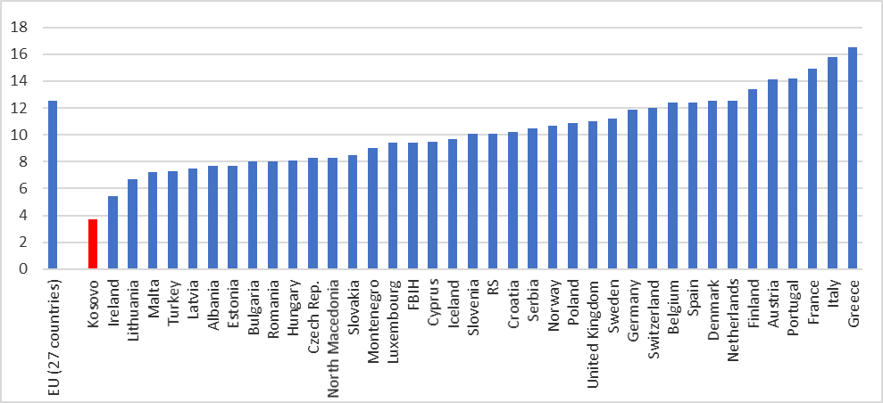
Source: Eurostat, pension agencies in Western Balkans countries.
Despite its different financing mechanism and benefits determination, the pension of €200 per month provided by the contributory system in Kosovo is in line with what other systems in the Western Balkans provide in terms of average benefits with respect to average gross wages, albeit in the case of Kosovo this is not a lifetime benefit. This benefit is equivalent to 38.5 percent of average gross wages, higher than the benefit ratios observed in Bosnia and Montenegro, but lower than the ones observed in Serbia, North Macedonia, or Albania (Figure 5). If we add the universal basic pension of €90 per month (which is a lifetime benefit), benefit generosity in Kosovo improves in relative terms.
Figure 5: Benefit Ratio (Average Pension to Average Gross Wages)
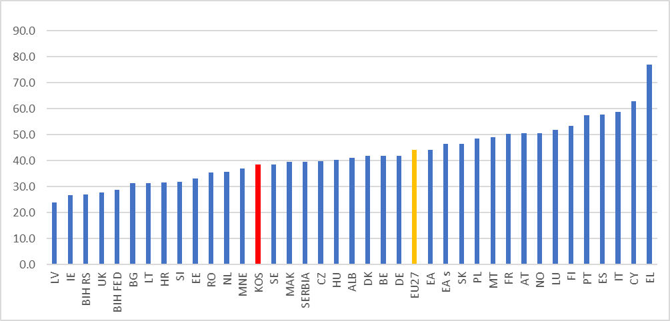

Source: European Union (EU) Aging Report 2018, PAYG pension agencies in Western Balkans countries and KPST.
As seen in Figure 6, contribution rates in Kosovo are low by European standards but are in line with Organisation of Economic Co-operation and Development (OECD) countries that rely heavily on individual accounts for their pension system (for example, Australia and Chile). For comparison, in Chile the contribution that goes into the individual account is also 10 percent of wages, but fees and the premium for the survivors and disability insurance are added on top of that contribution, increasing the total contribution to an average of 12.38 percent.
Figure 6: Social Security Contribution Rates (OECD and European Countries)

Source: OECD, Pensions at a Glance 2018. Pension agencies in Western Balkans countries.
- Recommendations
The Government of Kosovo has been working on a reform of the pension system since 2018, first with a concept document that was submitted for public consultation and then in the framework of an ad hoc Commission in Parliament. The new administration has also indicated that it will undertake a reform of the pension system and will likely resume this work.
The reform will need to tackle the fragmentation and increasing fiscal costs that derive from the proliferation of categorical pension benefits over the years. At the same time, it needs to address the adequacy of benefits by providing a predictable lifetime income stream that is sustainable, affordable, and that can be financed within the system instead of relying on general budget financing.
Despite a fragmented system and increasing pension costs, Kosovo has built the core design of its pension system based mainly on a basic non-contributory pension and a fully funded system of individual accounts.
World Bank Support and Recommendations
The World Bank has provided comments and recommendations to the Government of Kosovo on pension reform options, with the aim of building an integrated pension system comprising multiple pillars. The specific measures that have been proposed include the following:
- Redesign the basic pension such that it provides a minimum floor and is reduced according to other sources of pensions the individual has. Assess feasibility of establishing an ‘affluence test’ to exclude 20 percent of the highest income earners from receiving it.
- Redesign the payout phase of the second pillar to provide a pension for a fixed period of time (for example, 15 years) that is dependent on the accumulation in the account at the time of retirement.
- Introduce a new insurance pillar to finance benefits at an advanced age (after the individual account pension is exhausted), financed by an additional contribution rate and managed by an independent entity (preferably the existing KPST, to avoid additional institutional burden).
- Phase out ex-contributory benefits by linking their value to the value of a self-financed pension in an inversely proportional way such that ex-contributory benefits decrease as accumulations in the individual account increase.
- Consolidate existing categorical benefits as much as possible, especially disability benefits and war related categories.
In addition, the system needs institutional strengthening to improve its capacity to analyze and assess the long term impacts of the reform, as well as rationalize the decision-making process, to avoid future proliferation of benefits without proper long-term funding.
The World Bank can support the Government of Kosovo using its regional ASA on Pensions in the Western Balkans to develop some of these proposals, and by including some institutional and legislative measures in the potential Development Policy Financing (DPF) operation under discussion with the government.

Annex 1
Description of existing pension programs in Kosovo from the ‘Concept Document for Regulating and Managing the Field of Pensions and Benefits from Social Security’, published for consultation by the MLSW, October 2018.
Table A1: Summary of Pension Schemes
Scheme | Criteria | Monthly Amount
Pensions regulated by Law No. 04 / L-131 on State Pension Funds
Basic Pension Scheme | Age 65 years  Permanent residence in Kosovo  Citizenship of Kosovo  Presentation to MLSW every 6 months | €75
Ex-Contributor Pension | Age 65 years  Permanent residence in Kosovo  Presentation to MLSW every 6 months  At least 15 years contribution to the pension system in the former Yugoslavia before 1999  Recognition of work experience in 1989–1999 education, healthcare workers, and so on  Categorization of users according to the qualification structure:  1) Low-level pensioners  2) Secondary school retirees  3) High school graduates  4) Pensioners with superior education. | €158  €172  €186  €230
Pension Scheme of Permanent Disability | Age 18–65 years  D is for permanent disability (100%)  Permanent residence in Kosovo  After 1, 3, or 5 years (depending on the assessment), the beneficiary submits to the Medical Commission for medical reassessment | €75
The Early Pension Scheme of the ‘Trepça’ Complex | Permanent residence in Kosovo  Age 50–65 years  A proven contribution of at least 10 years in the mining sector (includes the period of dismissal during the 1990s)  Limited work ability up to 50%  To have no income from employment or self-employment | €105
Pension Scheme of Kosovo Protection Corps Members (KPC)  Law No. 03 / L-100 on Pensions of Members of the Kosovo Protection Corps | Minimum age: 45 years  Service in KPC for at least 5 years  Pensions are paid after the age of 65 years, together with the basic pension and the contributing pension. | 45 years of age—50% of the last salary of the KPC  50 years old—70% of the last salary from the KPC  Survivors (family) can benefit: spouse 60% and children 20% (regardless of number, up to 18 years of age, 26 years if the latter goes to school) of the pension paid to the KPC pensioner .
Pension Scheme for Members of the Kosovo Security Force (KSF)  Law no. 04 / L-084 on Pensions of Members of the Kosovo Security Force | Minimum age: 50 years or 55 years (in the case of officers)  Minimum 20 years contribution  Former KPC members continuing KSF service may retire after 3 years of service in KSF. | 60% of the last salary, 40% of the final salary up to the age of 50, and then 60% (in the case of KPC service)  Survivors (family) can benefit: spouse 60% and children 10% (up to 40%, regardless of number, up to 18 years of age, 26 years if the latter continues education) of the pension that was paid to the KSF pensioner.
Pension Scheme for Blind Persons  Law no. 04 / L-092 on Blind Persons | Beneficiaries: blind persons regardless of age | Not less than €125 (+ €125 for the personal assistant if the Commission deems it necessary)  Amount to be set based on minimum wages.
Other pension schemes - start implementing in 2017
Labor Invalidity Pension  Law No. 04 / L-131 on State Pension Funds  (Still not implemented) | Beneficiaries:  1. Persons under the age of 65 who have received the same pension before 1999  2. Persons suffering from work injury resulting in permanent disability (100%) (criterion for benefit for work injuries after 1999) | €75
Familiar Pensions  Law No. 04 / L-131 on State Pension Funds  (Still not implemented) | Beneficiaries:  1. Persons who received family pensions before 1999  2. Families that survive the family member who has been insured and contributed to the system before 1999 for at least 15 years  3. Families of persons who die from accidents at work or occupational diseases, irrespective of their contributions to the system before 1999.  Retirement for employment or self-employment is forbidden. | €75 + 20% for each child under 18 years or even 26 years in case of study
Pension Scheme for Tetraplegic Persons  and Paraplegics  Law no. 05 / L-067 on the Status and Rights of Paraplegic and Tetraplegic Persons | Beneficiaries: persons with paraplegia and tetraplegia | €170 (+€170 reimbursement for the guardian, + 50% of additional compensation depending on the condition of the disability)
Scheme for the Former Political Complainant and Persecution  (Not yet started implementation) | Beneficiaries' categories:  - Former political prisoners  - Former political prisoners  - Former political persecuted. | Adjusted by a special act. It has not yet entered into force.
The second and third pillar of the pension system
Mandatory Pension Savings for Workers (second tier)  Regulation no. 2001/35 on Pensions in Kosovo | Workers and other people active in the labor market  Contributions: 5% employee, 5% employer  65 years old (possible early withdrawals only if the contributor incurs 100% disability) | Not less than €150.
Voluntary supplementary pensions  Regulation no. 2001/35 on Pensions in Kosovo | Supplementary Employer Pension Funds:  - Established as non-profit legal entities  - Subject to licensing and regulation  Supplementary Individual Pensions:  - Provided by financial institutions, banks and insurance companies  - Subject to licensing and regulation
Source: Legislative Legislation for each Scheme and Social Statistics 2015, KAS, 2016.
Table A2: Categories of Pensions for Categories out of War
Scheme | Criteria | Monthly Amount
For War Veterans of the Kosovo Liberation Army (KLA).  Law no. 04 / L-261 for War Veterans of the Kosovo Liberation Army | Veteran KLA fighter—a Kosovo citizen and a foreign citizen who is listed in the KLA and is registered as an armed and uniformed soldier from KLA commands, staff and operational areas and who was active until the end of the war  Under age 65 years  Veterans employed in the public and private sector do not have the right to retire.  In the case of KPC service, it may select a pension between the KPC or a veteran warrior.  Unemployed spouse, minor children, and parents if they do not receive social insurance benefits. | €170 (the minimum wage value); after reaching the statutory retirement age, is entitled to an additional allowance for the retired veteran's pension.  Veteran's family, after the death of the veteran: 70% of the spouse's or child's pension (up to 18 years or 26 years, depending on the continuation of education): €119.
Status and Rights of Martyrs, Invalids, Veterans, KLA Members, Victims Sexual Violence, Civil Victims and their Families (Law No. 04 / L-172 on Amendments and Supplementation of the Law No.04 / L-054 on the Status and Rights of Martyrs, Invalids, Veterans, Liberation Army Members Kosovo Victims of Sexual Violence of War, Civilian Victims and their Families)
Pensioners of Martyrs' Families | A close family member  Children of martyrs' families without parental care are beneficiaries of the family pension and enjoy the right to 18 years of age, or 26 years of age if they are attending regular education. | The family who has given a martyr: €448.13  The family who has given two martyrs: €537.76  The family who has given three martyrs: €582.57  The family who gave four martyrs: €627.39  The family who has given more than four martyrs: €672.19
Pensions of the KLA Families of the KLA | A close family member  Children of missing KLA without parental care are beneficiaries of the family pension and enjoy the right to 18 years of age, or 26 years of age if they are attending regular education. | Family with one KLA missing: €448.13  Family with two KLAs missing: €537.76  The three missing KLAs family: €582.57  The four missing KLAs family: €627.39  Family with more than four missing KLAs: €672.19
Pensions of Families of Victims and Missing Civilian | The order is husband or wife, children, illegitimate children, adopted children, parents, stepson, stepdaughter.  The spouse who enters into a new marriage shall lose the rights set forth in this law.  Children of the victim or civilian missing without parental care are beneficiaries of the family pension and enjoy the right to 18 years of age, or 26 if they are attending regular education. | Family with one victim or missing person: €168.75  Family with two casualties or missing civilians: €202.50  Family with three casualties or missing civilians: €219.38  Family with four casualties or missing civilians: €236.25  Family with four or more casualties or missing civilians: €253.13
Invalidity Pension of the KLA | Invalids with 20–100% of bodily harm are entitled to retirement. | Invalid with over 80% body injury: €448.13  Invalid with 71–80% bodily injury: €412.5  Invalid with 61–70% body injuries: €393.75  Invalid with 51–60% bodily harm: €375  Invalid with 41–50% bodily harm: €356.25  Invalid with 31–40% bodily harm: €318.75  Invalid with 21–30% bodily harm: €225
Civil Invalids Pensions of War | Invalids from civil war with 40–60% degree of disability. | Invalid with over 80% bodily harm: €152.5  Invalid with 61–80% bodily harm: €136.25  Invalid with 40–60% bodily harm: €120  + caretaker for over 80% bodily injury: €50.13
Invalidity pensions of the KLA after the death of the Invalid | The spouse who enters into a new marriage after the death of the invalid loses the right to pension and benefits.  KLA children without parental care are beneficiaries of the family pension and are entitled to enjoy up to the age of 18 years, or 26 years if they are attending regular education.  Families of war-wounded KLA invalids who die as a result of these injuries (within 3 years after the war) have the right to a family pension at 100% disability. | Invalid with over 80% bodily harm: €385.50  Invalid with 71–80%bodily harm: €330  Invalid with 61–70% bodily harm: €315  Invalid with 51–60% bodily harm: €300  Invalid with 41–50% bodily harm: €285  Invalid with 31–40% bodily harm: €255  Invalid with 21–30% bodily harm: €180
Nursing Pensions of KLA Invalids | For invalids with 81–100% degree of disability | €225
Children of Civil Invalids of War after Death of Invalids |  | Invalid with over 80% physical impairment: €123.25  Invalid with 61–80% physical injury: €110.25  Invalid with 40–60% bodily injury: €97.25
Source: Legislative Legislation for each Scheme and Social Statistics 2015, KAS 2016.

This note was prepared under World Bank’s Advisory Services and Analytics (ASA) activity for Western Balkans Pensions in Q1 2020. It does not capture the developments during and after the global Covid-19 pandemic and its potential impact on the pension system in Kosovo. Analysis of the effects of Covid-19 on pensions in Kosovo, policy responses undertaken by the authorities, and further policy options will be carried through follow-up ASA for Western Balkans and other World Bank programs and activities.
See Annex 1 for a description of all pension benefits currently existing in Kosovo.
Final figures for 2019 are not yet available.
Since KPST records the withdrawal of the full account balance at the time of retirement, the figure of total pension payments in a year cannot be obtained from KPST financial accounts.
Alternatively, this benefit could be financed by general revenue as a compensatory measure to the clawback of basic pensions, such that the longevity risk would be borne by the State instead of the individual.
Increased to €90 in 2019.
Increased by 15 percent in 2019.
Increased by 20 percent in 2019.

