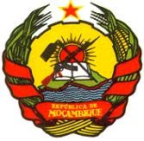

Government of Mozambique

Cyclone Idai and Kenneth Emergency Recovery and Resilience Project (P171040)

STAKEHOLDERS ENGAGEMENT PLAN
(SEP)

31 March 2020

CONTENTS:
1. Project Context 1
2. Project Description 3
2.1. Project Objectives 3
2.2. Project Components 3
3. Legislative and Environmental and Social Standards Requirements 10
4. Previous Stakeholder Engagement Activities 10
5. Stakeholders Identification and Analysis 11
5.1. Stakeholder identification and Analysis 11
5.2. Disadvantaged / Vulnerable Individuals and Groups 13
5.3. Summary of Project Stakeholder Needs 14
6. Stakeholder Engagement Program 18
6.1. Proposed Strategy for Information Disclosure 18
6.2. Proposed strategy for consultation and timing 19
6.3. Proposed Strategy to incorporate the View of Vulnerable Groups 21
6.4. Timelines 21
6.5. Reviews of Comments 21
6.6. Future Phases of Project 22
7. Resources and Responsibilities for Implementing Stakeholder Engagement Activities Resources 22
7.1. Management Functions and Responsibilities 22
8. Grievance Redress Mechanisms 23
8.1. Grievance Redress Process 23
8.2. Community Level Grievance Redress Mechanism 23
8.3. Project Level Grievance Redress Mechanism 24
8.4. Judiciary Level Grievance Redress Mechanism 24
9. Monitoring and Reporting 25
9.1. Involvement of Stakeholders in Monitoring Activities 25
9.2. Reporting Back to Stakeholder Groups 26
ANNEX 1: Public consultation attendancy register 27
ANNEX 2 – Cost Estimate of ESHS preparation, supervision and implementation (Sep 2019) 34
ANNEX 3 – PIU Organizational Chart 38

TABLE LIST:
Table 1. Planned emergency activities under the IRM/CERC. 8
Table 2. Stakeholder’s categorization. 12
Table 3. General Categories of Vulnerable groups 14
Table 4. Project Stakeholders matrix 15
Table 5. Proposed consultation and disclosure techniques. 18
Table 6. Proposed consultation Plan 20
Table 7. Grievance Redress Process at Project Level. 24

FIGURE LIST:
Figure 1. Cyclones Idai (a) and Kenneth (b) 2

- Project Context
In March and April 2019, Mozambique was struck by two consecutive major cyclones with significant impacts on local population, business and core infrastructure. A total of 1.5 million people were affected, with damages and losses amounting to US$ 2.79 billion, and an estimated US$ 3.2 billion of total cost for recovery and reconstruction. The first event, Cyclone Idai, affected more than 1.5 million people (5.4 percent of Mozambique population) causing 602 fatalities and 1,600 injuries. Cyclone Idai also had significant impacts in neighbouring countries Malawi and Zimbabwe. The second event, Cyclone Kenneth, affected 250,000 people and caused 45 casualties. Both events destroyed and damaged houses, business and core infrastructure. Given the severity of the impacts of the two cyclones in Mozambique, the World Bank’s proposed response combines the strategic use of IDA resources on multiple fronts to enable a response at scale, drawing from resources under ongoing projects where possible; activation of CERC/IRM components; and a proposed CRW allocation.
The impacts of Cyclones Idai and Kenneth are concentrated in the provinces of Sofala, Zambezia, Manica and Cabo Delgado. Cyclone Idai caused extraordinary levels of impact in Sofala, Zambezia and Manica. Six weeks after Cyclone Idai, Cyclone Kenneth made landfall in the fragile Province of Cabo Delgado. Idai’s U-shaped path passed over Zambezia, Nampula and Tete provinces in the first week of March. It then came back through Sofala, Manica and Tete during the end of the second week making landfall near the city of Beira, in Sofala Province. The city, Mozambique’s 5th largest with a population of over 530,000, was hit hard by both cyclone-level wind speeds (>175km/h) as well as torrential rainfall and storm surge. The cyclone caused massive destruction resulting from both flooding and very strong winds, resulting in severe economic and social impacts for affected populations. Six weeks after, cyclone Kenneth, a category 4 cyclone considered the strongest cyclone to ever hit the African continent, brought winds of up to 220 km/h causing massive destruction to homes and infrastructure in the districts of Ibo, Macomia and Quissanga. Kenneth slowly moved south towards the city of Pemba, population 200,000, causing major flooding in its path.

Panel (a). Cyclone Idai  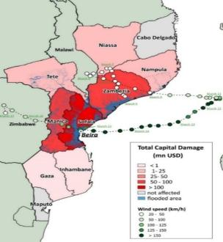  Source: World Bank | Panel (b). Cyclone Kenneth  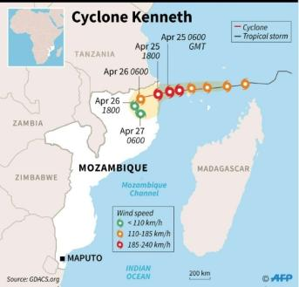  Source: MeteoFrance
Figure 1. Cyclones Idai (a) and Kenneth (b)
A Post Disaster Need Assessment (PDNA) was conducted in April and May 2018 in partnership with Government and non-Government actors, quantifying the damages, losses and negative repercussions on poverty and economic growth. The post-disaster needs assessment was carried out in collaboration between the GoM, United Nations (UN), African Development Bank (AfDB), European Union (EU) and the World Bank, covering the entire affected areas, including areas affected by Cyclone Kenneth. In addition, the World Bank conducted a remote “GRADE” impact assessment and the Municipality of Beira conducted a city-wide assessment process with support from the Dutch Government and other international partners. The PDNA shows highest damages and losses in productive (US$ 1,191 million), infrastructure (US$ 797 million) and social (US$ 693 million) sectors. The impacts of the recent events estimated in the PDNA are significant, including the increase on poverty rate, decrease on economic growth and increase in inflation, which could worsen the actual situation of food insecurity in the country. It is estimated that the poverty rate may rise to 79 percent in affected areas, up from 64 percent. Preliminary forecast on GDP point to a decrease in real GDP from 4.7 percent to 2.4 percent.
Due to the strategic importance of the Beira corridor for international trade, the damages to critical infrastructure and logistics in and around Beira are expected to have ripple effects on neighbouring countries, in addition to the negative effects on the local economy. The Beira corridor is a trading route for countries including Malawi, Zambia and Zimbabwe that links hinterland countries to the ocean through the port of Beira. Cyclone winds and floods destroyed or damaged critical infrastructure, such as roads and bridges, as well as buildings in Beira used to facilitate trade, such as warehouses. The capacity of the region to facilitate trade is expected to decrease as a consequence of Cyclone Idai. This may have long term impacts, as businesses search for alternative trading routes during the disruption. Some may not return when services have recovered. Local businesses have suffered major damages and losses. In addition to the direct costs associated with damages to facilities and equipment, local enterprises suffered from the indirect effects of infrastructure disruptions, as well as demand and supply shocks.
The Government of Mozambique has been activated mechanisms to respond to the emergency with an extensive support of donors since the declaration of the state of emergency on March 19. And following the landfall of Cyclone Idai, it launched a major rescue operation while providing humanitarian aid to affected population, including more than 150,000 people temporarily relocated to emergency shelters. The post-disaster response was carried out by the National Institute for Disaster Management (INGC), a Government agency, with support from the UN system and multi and bilateral organizations. In addition, the Government completed a Post-Disaster Needs Assessment supported by the EU, UN, AFDB and World Bank covering the entire affected areas, including areas affected by Cyclone Kenneth. The PDNA was coordinated by the Ministry of Public Works, housing and Water Resources and the outcomes were presented at the Donor Conference on June 1, 2019. To support the government response, pledges towards humanitarian and development needs add up to close to US$214.3 million for Mozambique specific support. To fund the humanitarian relief effort in Mozambique, the UN launched a Flash Appeal for an amount of US$282 million. The major share of the appeal amount was dedicated to food security and health to assist the 1.72 million people in need of immediate life-saving and life-sustaining assistance over the 3 months following the disaster. About US$94.3 million was pledged by donors towards the appeal. The United States (US$48.2 million) and United Kingdom (US$5.6 million) made the largest country contributions to the pledge. US$19 million was funded by the Central Emergency Response Fund (UN). In addition, the IMF approved emergency financial assistance of US$120 million for budgetary support.
Besides the above, an outbreak of the coronavirus disease (COVID-19) caused by the 2019 novel coronavirus (SARS-CoV-2) has been spreading rapidly across the world since December 2019, following the diagnosis of the initial cases in Wuhan, Hubei Province, China. Since the beginning of March 2020, the number of cases outside China has increased thirteen-fold and the number of affected countries has tripled. On March 11, 2020, the World Health Organization (WHO) declared a global pandemic as the coronavirus rapidly spreads across the world. As of March 24, 2020, the outbreak has resulted in an estimated 334,981 cases and 14,652 deaths in 189 countries. The disease has already been reported across continents, and within the Southern African Development Community (SADC) member countries, including Mozambique there are reported cases of COVID-19
The SEP under the IRM-CERC for COVID-19 Pandemic activation was prepared based on the existing safeguards documents approved for Cyclone IDAI and Kenneth in Mozambique.

- Project Description
  - Project Objectives
The Project Development Objective is to support the recovery of public and private infrastructure and strengthen climate resilience of the areas most affected by Cyclones Idai and Kenneth.
  - Project Components
The proposed project addresses short- and medium-term reconstruction needs while strengthening long-term resilience of the affected areas. The proposed reconstruction interventions follow the priorities as identified in the Post-Disaster Needs Assessment which was developed by the GoM, World Bank, UN and EU, and presented at the Reconstruction Conference in Beira on June 1st, 2019. The project will focus on (1) the resilient reconstruction of housing and selected public infrastructure assets; (2) financial support to aid the recovery of the private sector; and (3) investments in the recovery and strengthening of climate resilience infrastructure.
The project will address recovery needs in the coastal provinces most affected by Cyclone Idai and Kenneth and will support climate resilience investments in the city of Beira. The coastal provinces of Sofala and Cabo Delgado have borne the brunt of Cyclone Idai and Kenneth, respectively. The project will prioritize recovery of housing and public infrastructure across these two provinces. Being one of the most important and fastest growing centers of economic activity in Mozambique, the city of Beira in the province of Sofala accounts for a large share of the economic impact of Cyclone Idai. Currently, the city has 530,000 inhabitants, while the population is expected to double in 10-15 years. The project will therefore prioritize investments in climate resilience infrastructure in this city.
Component 1 – Recovery and reconstruction of cyclone-affected areas (US$80 million IDA)
The activities to be financed under this component include (1) the repair and reconstruction of housing for selected vulnerable communities; (2) the repair and reconstruction of key public infrastructure; and (3) technical assistance to enable the GoM and affected communities to apply Building Back Better (BBB) principles in the reconstruction phase.
Sub-component 1.1 – Housing (US$42 million IDA)
The sub-component will finance the reconstruction of approximately 5,000 hazard-resilient housing units for an estimated 25,000 cyclone-affected beneficiaries through a community-based reconstruction approach. The housing reconstruction activities will prioritize affected areas in Sofala and Cabo Delgado.
The targeting of activities under this sub-component will be tailored based on a housing reconstruction strategy that will be completed by the Reconstruction Office in the first months after project effectiveness. The strategy will be based on three complementary assessments: (1) a housing assessment that will identify the typologies of affected houses and the appropriate reconstruction options; (2) a social assessment of affected households that will cover the households’ economic situation, composition, gender roles and reconstruction investments to date; and (3) a value chain analysis to assess the market conditions for the housing reconstruction and flag any possible labour or material limitations. The targeting and implementation of the housing reconstruction activities under this sub-component will inform operational modalities for the Government’s wider reconstruction program that will address the needs identified in the Post-Disaster Needs Assessment.
The implementation arrangement, including the financing flows, will be based on the specifics of the reconstruction strategy. Likely, the construction will be implemented through a hybrid approach involving community-level construction, technical support from NGOs and UN organizations and a grant system through the Reconstruction Office. A technical support program will be established that will build capacities for Building Back Better approaches across government and non-government agencies. The technical assistance will include (1) the hiring of specialized consultants to assist the Government in the development of the required strategic assessments and their implementation; (2) the organization of tailored training programs for government and non-government agencies involved in the reconstruction; and (3) the establishment of community-level training programs to strengthen the reconstruction process.
Sub-component 1.2 – Public Infrastructure (US$16 million IDA)
This sub-component will finance the recovery and reconstruction of key public infrastructure damaged by Cyclones Idai and Kenneth, and the construction of new public resilience infrastructure. Specific activities financed may include the repair and reconstruction of markets, government buildings, public water and sanitation units; and the construction of multi-functional elevated flood evacuation sites and cyclone wind shelters.
A designated recovery strategy including a list of public infrastructure priorities will be developed in the first months after project effectiveness, based on the Post-Disaster Needs Assessment and further data collection. The strategy will inform the interventions to be financed under this sub-component.
Sub-component 1.3 - Private Sector Recovery (US$22 million IDA)
This component will target informal, micro, small, and medium sized firms impacted by the disaster. To support their recovery, the project would utilize a combination of interventions along the following lines:
- Matching grant. To help firms purchase equipment or materials and would also provide working capital to support recovery effort.
- TA to firms. Would be provided to firms both before and after firms make an application for a matching grant.
- TA to participating financial institutions. To help tailor emergency response products.
- Credit line. To provide temporary liquidity for working capital and investment financing during the emergency reconstruction phase.

In terms of sequencing, the TA could move relatively quickly and would support eligibility verification, preparation of business plans, and help develop the pipeline of applicants. The TA would support beneficiaries from matching grant application to implementation. It would be delivered by a private service provider. The credit line would rely on identification of a financial intermediary and would initially target micro-finance institutions but could also be eligible for small to medium-sized commercial banks. The matching grant would be administered along similar lines to the catalytic fund under the Growth Poles Project.
Component 2 – Building Climate Resilience (US$60 million IDA plus US$60 million co-financing from DRIVE Program)
The proposed project presents a holistic approach to recovery and reconstruction while reducing the vulnerability of the affected areas to climate-related hazards. This component will strengthen the resilience of the city of Beira to future climate hazards, by (1) repairing and significantly strengthening coastal protection; and (2) expanding the rehabilitated drainage system to reduce flooding in vulnerable parts of the city.
The geographical scope of this component is limited to vulnerable parts of Beira, due to the increasing priority of the city as a regional economic hub and the fact that Beira suffered the major share of the combined economic losses from the two cyclones.
Sub-component 2.1 – Coastal Resilience (US$30 million IDA, plus US$30 million co-financing)
Beira’s coastline is vulnerable to storm events and continuous erosion. The main flood protection system that protects the city from coastal hazards has been constructed more than 50 years ago and has deteriorated with limited maintenance since its construction. Cyclone Idai damaged this already weakened coastal protection infrastructure and caused over several million US$ damage to coastal infrastructure. However, due to the fact that the landfall occurred at low tide, the city escaped widespread coastal flooding. Cyclone Idai was therefore a strong wake-up call for the repair and rehabilitation of the coastal protection system.
In the aftermath of Cyclone Idai, the Government with support from the Dutch Government conducted a comprehensive assessment of the vulnerabilities in the coastal protection system. The assessment quantified damages, losses and needs to the coastal protection system, and concluded that the coastal protection system urgently needs rehabilitation and strengthening to protect the city from coastal flooding. The total needs for repairs and upgrades to the coastal protection system are estimated at US$90.9 million, which includes the repair and reconstruction of the existing groins, flood walls and dunes, and the rehabilitation of degraded beaches.
This sub-component will address key gaps in Beira’s coastal protection system, by (1) repairing damage to the coastal protection and coastal road caused by Cyclone Idai; (2) rehabilitating and strengthening the groins, dunes and flood walls; and (3) conducting strategic sand nourishment to replenish the sand balance across the target area.
The works under this sub-component will be co-financed on a 50%/50% basis by the Government of the Netherlands through the DRIVE program. The DRIVE Program will finance 50% of the firm contract under this sub-component with a maximum of €30 million (US$34 million). A Letter of Intent has been sent and a separate Grant Agreement will be signed between the Government of the Netherlands and the Government of Mozambique.
Sub-component 2.2 – Drainage Rehabilitation (US$30 million IDA, plus US$30 million co-financing)
The drainage investments financed by the Bank under the Cities and Climate Change Program were effective in minimizing flooding during Cyclone Idai. Beira suffered flooding in January 2019 in areas without rehabilitated drainage infrastructure and saw additional flooding during Cyclone Idai in those areas not serviced by the rehabilitated drainage system.
This sub-component will repair cyclone-induced damages to the drainage works and implement Phase 2 of the drainage rehabilitation. Cyclone Idai caused minor damages to the current drainage system that will be repaired under this sub-component. The works completed to date only covered Phase 1 of the drainage rehabilitation needs of Beira. It was recognized in 2015, upon completion of the detailed design of the Phase 1 works, that this investment needed urgent follow-up with the study and implementation of Phase 2. This would focus on Chota and Estoril and deal with the rehabilitation of canals A1 and A3, including an additional retention basin and outlet to the eastern coast. AIAS has already commissioned a study to demonstrate the feasibility of these Phase 2 drainage works, prior to the availability of funding and prior to the passage of Cyclone Idai.
The works under this sub-component will be co-financed on a 50%/50% basis by the Government of the Netherlands through the DRIVE program. The DRIVE Program will finance 50% of the firm contract under this sub-component with a maximum of €30 million (US$34 million). A Letter of Intent has been sent and a separate Grant Agreement will be signed between the Government of the Netherlands and the Government of Mozambique.
Component 3 – Project Implementation, Monitoring and Evaluation (US$10 million)
This Component will support the implementation of all project activities, through establishing and strengthening the capacity of the Reconstruction Office and AIAS (responsible for implementing Component 1 and 2, respectively) with respect to (a) technical capacity with respect to the implementation of reconstruction and resilience interventions, including coastal resilience and housing; (b) fiduciary (i.e. financial and procurement management); (b) environmental and social assessments; (c) preparation of Project reports; and (d) monitoring and evaluation.
This Component will support tailored training and capacity building activities related to the best practices in post-disaster reconstruction following the Building Back Better approach, in order to strengthen the implementation of all components.
COMPONENT 4: Emergency COVID-19 Response [US$ 73.5 million]:
This component would provide immediate support to Mozambique to prevent the spread of COVID-19 from incoming cases and limiting local transmission through containment strategies in line with Mozambique COVID Preparedness and Response Plan. The component has two areas of intervention under (i) Ministry of Health focusing on health related activities and (ii) INAS providing social protection support to the urban poor. The health related interventions will support the strengthening of disease detection capacities through provision of technical expertise, laboratory equipment and systems to ensure prompt case finding and contact tracing. It would strengthen Institution and community engagement in ensuring community-based disease surveillance and multi-stakeholder commitment to keep the public informed and empowered to obey to social distancing non-pharmacological interventions (i.e. schools closing, offices shutting down). Lastly, it would enhance clinical care capacity through financing plans for establishing specialized units in selected hospitals, treatment guidelines, clinical training of health workers and hospital infection control guidelines.
The Social Protection related interventions will provide cash transfers to an estimated 250,000 urban poor households in urban areas. The payment will consist of MZN 1,500 per month for 6 months. INAS currently covers about 85,000 urban households, possibly more when including those in waiting lists. The expansion of coverage should be based on a geographic prioritization where risks are higher due to congestion (poorest bairros in urban and peri-urban settings),2 infection hot spots (to be informed by MINSAU), or population and economic activity (e.g. local markets). Household prioritization should include families with higher risk like elderly, HIV prevalent, children, among other criteria. Special attention should be placed in implementation in areas with high social sensitivity to also reduce risks of social unrest in (peri)urban settings.
Sub-component 4.1 – Prevention through Risk communication, community engagement and social distancing [US$ 7,200,000]: Establish national risk communication and community engagement strategy for COVID19; adaptation of the messages to the poorest and most vulnerable populations which are the target beneficiaries of the Social Safety Net (SSN) programs; production of communication materials and training resources for risk communication for COVID19; proactive public outreach on a mix of platforms (newspapers, radio, television, social media, Internet) including; stakeholders mapped and decentralized institutional system in place for community engagement and financing for non-pharmaceutical interventions (NPI): everyday personal (hands hygiene, cough etiquette, stay home if ill), environmental (clean surfaces, increase ventilation), pandemic personal (home if anyone in the household is ill, using mask in community if ill), pandemic community (school closing, teleworking, cancel mass gatherings). In the mid-term (end of the project), the goal would be to have a National Strategy for Risk communication and community engagement;
Sub-component 4.2 – Case Management - Health systems capacity to respond to COVID19 [US$ 12,300,000]: Establish healthcare referral and triage systems for COVID19; upgrade and equip health care facilities to increase ICU capacity with medical equipment and supplies for COVID19 severe patients management; establishment and Training of Emergency Medical Teams (EMTs) to respond to COVID19 emergency; draft and disseminate guidance on ICU management of severe cases with proper IPC; ensure water supply, sanitation and hygiene services and medical waste management in health care facilities; procurement of commodities for IPC precautions (personal protection equipment); develop plan to support critical functions that must continue during a community widespread outbreak of COVID19 (e.g. water and sanitation, fuel and energy, food, telecommunication/internet, finance, education, and transportation, necessary resources, and essential workforce); and case detection, confirmation, contact tracing, recording, reporting through strengthen national laboratory diagnostic to conduct COVID19 diagnostic tests as well as in the mid-term build capacity for key priority diseases in accordance to WHO guidance.
Sub-component 4.3 – Communication and Panic Management [US$ 500,000]: Implement national risk-communication and community engagement plan for COVID‑19, including details of anticipated public health measures.
Sub-component 4.4 – Social Protection for the Vulnerable groups [US$ 53,300,000]: Payments to INAS beneficiaries of MTZ 1,500 per month for the next 6 months to support purchasing capacity of INAS participants, especially in urban areas. This support will improve the impact on the livelihoods of the urban poor who are most vulnerable to economic and health shocks in the pandemic situation. The payments will mostly be made through digital means through mobile phone service providers. Provision of complementary humanitarian assistance for an initial emergency phase of 3 months will be also included under this component.

Table 1. Planned emergency activities under the IRM/CERC.
Areas of Intervention | Activities | Responsible Agency |  | Cost  (in USD millions)
Prevention | Provide prioritized tailored support to health facilities based on Infection Prevention and Control (IPC) risk assessment and local care-seeking patterns, including for supplies, human resources, training | MISAU & Local Partners |  | 7.2
 | Assess IPC capacity at all designated health care system, including public, private. Minimum requirements include functional screening system and isolation rooms, trained staff (for early detection and standard principles for IPC); and enough IPC materials, including personal protective equipment (PPE) and WASH services/hand hygiene stations
Case Management | Prepare rapid health assessment/isolation facilities to manage ill passenger(s) and to safely transport them to designated health facilities | MISAU |  | 12.3
 | Equip COVID treatment center in all provinces
 | Prepare staff surge capacity and deployment mechanisms; health advisories (guidelines and SOPs); pre- and post-deployment package (briefings, recommended/mandatory vaccinations, enhanced medical travel kits, psychosocial and psychological support, including peer support groups) to ensure staff well-being
 | Map available resources and supply systems in health and other partners; conduct in-country inventory review of supplies based on WHO’s a) Disease Commodity Package (DCP) and b) COVID‑19 patient kit, and develop a central stock reserve for COVID‑19 case management
 | Develop and implement surge plans to manage increased demand for testing; consider conservation of lab resources in anticipation of potential widespread COVID‑19 transmission
Communication, and panic management | Implement national risk-communication and community engagement plan for COVID‑19, including details of anticipated public health measures | MISAU and Partners |  | 0.5
 | Preparation of daily and weekly SITREPS and dissemination at national level and partners.
 | Establish a 24-hour COVID-19 hotline telephone alert system
Social Protection to the Vulnerable groups | Advanced payments to INAS beneficiaries for the next 6 months to support purchasing capacity of INAS participants, especially in urban areas in order to cope with Covid-19 and other emerging infectious diseases that can affect the functioning of the urban economies and have a negative impact in the poorest and most vulnerable populations  Top up benefits of INAS beneficiaries in rural areas to help cope with increased food prices and limited access to services  Advance payments in non-urban locations |  | INAS | 33.1
Strengthening Social Protection Systems | Enrolment of additional households using digital platforms and establishing reliable payment delivery mechanisms for the delivery of the cash transfers |  | INAS | 6.4
Workers protection | Provide INAS staff with adequate protection material to continuing developing field activities in a safety way |  | INAS | 0.5
 |  |  |  | 15
Humanitarian Assistance | Provision of complementary humanitarian assistance to the urban poor, such as, but not limited to, food and WASH services. |  | INAS  (through UN Agencies) | 13.5
TOTAL | 73.5

- Legislative and Environmental and Social Standards Requirements
Under the Mozambican Legislation, stakeholder engagement is required from early stages of a project conception, either as part of environmental and social impact assessment or land use rights acquisition.
According to decree 54/2015 of 31st December – Regulation for Environmental Impact Assessment, public consultation process is a compulsory activity for all Category A+, A and B projects. The Ministerial Diploma on the Directive for Elaboration of Environmental Impact Studies (129/2006) and Public Participation General Directive (Diploma 130/2006) outlines when and how should the public consultation process be conducted as well as disclosure requirements of the documentation under consultation.
The EIA Regulations defines the public participation process as an activity which involves public audience (with a minimum required 25 attendees) and public consultation. The public participation process implies delivery of information regarding projects to all directly and indirectly interested and affected parties, and an explanation of the project to enable participants to raise issues of concern for investigation in the ESIA.
The World Bank’s Environment and Social Standard 10 sets out that a Borrower has to engage with stakeholders as an integral part of a Project’s environmental and social assessment and project design and implementation. The nature, scope and frequency of the engagement should be proportional to the nature and scale of the Project. Consultations with stakeholders have to be meaningful and be based on stakeholder identification and analysis, plans on how to engage stakeholders, disclosure of information, actual consultations, as well as responses to stakeholder grievances, and reporting back to stakeholders.
- Previous Stakeholder Engagement Activities
The Environmental and Social Commitment Plan –ECP and Stakeholder Engagement Plan (SEP) constitute the initial stage of the CERRP prior to the project appraisal. In order to incorporate stakeholders ‘views are taken into account in this phase a public consultation meeting was held on 27th June with key institutional and civil society stakeholders in Beira city, the most affected area, where both documents were presented. The beneficiaries' contributions, including concerns and suggestions on various aspects of the project, were collected in order to complete the SEP ESCP before the review and approval of the project by the World Bank. (see attendance sheet in Annex 1).
Issues identified during the consultation with stakeholders present in the meeting included to make sure grievance redressing mechanism is well disseminated among the stakeholders, stakeholders’ engagement during the project´s environmental and social instruments preparation and project execution. The stakeholders were also interested to know the project implementation schedule and availability of funds for Idai recovery project.
- Stakeholders Identification and Analysis
  - Stakeholder identification and Analysis
An estimated 3,000 sq. km of land and 715,378 hectares of cultivated land were flooded by Cyclone IDAI. As of the end of April, 400,000 had been displaced, of which 160,927 were sheltering in 164 temporary accommodation centers across the four provinces. It is estimated that over 13.5 million people lived in the four provinces of Sofala, Manica, Zambezia and Tete, of which more than 1.5 million have been affected, over 1600 injured and more than 600 people died. An estimated 750,000 are in need of urgent assistance. About 53% of those in urgent need are women, 47% are men, 254,000 are children under 18 years of age, and 63,000 are over 60 years of age.
It Important to note is that these are ‘parties’ that have already been affected by disaster, and that will be beneficiaries of the Project, rather than being negatively affected by the Project. While not every affected party will also be a beneficiary, it is crucial to disseminate information and engage with all stakeholders on project modalities as well as on the selection criteria of beneficiaries in the affected areas. Furthermore, it is important that all processes of information disclosure and consultation are as inclusive as possible to ensure that all sections of the affected communities will benefit from the project, and women and vulnerable groups are not excluded.
In order to develop an effective SEP, it is necessary to determine who the stakeholders are and understand their needs and expectations for engagement, and their priorities and objectives in relation to the Project. This information is then used to tailor engagement to each type of stakeholder. As part of this process it is particularly important to identify individuals and groups who may find it more difficult to participate and those who may be differentially or disproportionately affected by the project because of their marginalized or vulnerable status.
It is also important to understand how each stakeholder may be affected – or perceives they may be affected – so that engagement can be tailored to inform them and understand their views and concerns in an appropriate manner.
Stakeholders have been and will continue to be identified on a continuing basis by identifying:
- Various stakeholder categories that may be affected by, or be interested in, the Project; and
- Specific individuals, groups, and organizations within each of these categories taking into account:
  - The expected Project area of impact, that is the geographical area over which it may cause impacts (both positive and negative) over its lifetime, and therefore the localities within which people and businesses could be affected;
  - The nature of the impacts that could arise and therefore the types of national/local government entities, NGOs, academic and research institutions and other bodies who may have an interest in these issues.
In general, engagement is directly proportional to impact and influence, and as the extent of impact of a project on a stakeholder group increases, or the extent of influence of a particular stakeholder on a project increases, engagement with that particular stakeholder group should intensify and deepen in terms of the frequency and the intensity of the engagement method used. All engagement should proceed on the basis of what are culturally acceptable and appropriate methods for each of the different stakeholder groups targeted.
Table 2. Stakeholder’s categorization.
Stakeholders that may be affected, directly or indirectly, by the results of the implementation of CRRP | Stakeholders that may take part in implementation of the Project | Stakeholders with influence in the implementation of the project
General affected population, displaced families, vulnerable population and civil society in general  Private sector  Small commercial farmers, subsistence farmers;  Public servants (health, education workers, public administration in general)  Vulnerable groups (e.g. elderly people, disabled, children, child headed families, female-headed households, pregnant women)  NGOs and Associations operating at local and Provincial levels  Provincial and District Government and Municipal councils  Small scale fisherman  Small Business  Population at risk of contracting COVID  People who are likely to face both health and economic shocks due to the COVID-19 pandemic  Digital payment providers  Medical and health staff | Post idai cyclone cabinet for Reconstruction  Project Implementation unit and Project Coordination Units from different Ministries  Central Government (Ministry of Public works)  Provincial Government (Directorate of Public Works, Education, Health, social welfare, Agriculture, Transport)  Beira Municipality Council Provincial, District and Municipal Governments  District Governments and Municipalities (Beira and Dondo Municipalities and governments of affected districts)  Contractors and service providers  NGOs (especially those working on Gender Based Violence, reconstruction process)  Providers of public services (Electricity of Mozambique, FIPAG, ANE)  INAS  MISAU | Central Government (Ministries of Planning and Finance, Agriculture, Land Environment and Rural Development, Health, Education, Transport and communication; Gender, Child and Social Protection)  Provincial Government of Sofala  NGOs and Associations (national and provincial)  International Organizations (UN Habitat, World Food Program, UNICEF, Water, World Health Organization), WHO  Universities and Research Institutions  National Disaster Management Institute  Media (local, national and International)

  - Disadvantaged / Vulnerable Individuals and Groups

COVID - 19
It is particularly important to understand whether project impacts may disproportionately fall on disadvantaged or vulnerable individuals or groups, who often do not have a voice to express their concerns or understand the impacts of a project and to ensure that awareness raising and stakeholder engagement with disadvantaged or vulnerable individuals or groups [on infectious diseases and medical treatments in particular,] be adapted to take into account such groups or individuals particular sensitivities, concerns and cultural sensitivities and to ensure a full understanding of project activities and benefits. The vulnerability may stem from person’s origin, gender, age, health condition, economic deficiency and financial insecurity, disadvantaged status in the community (e.g. minorities or fringe groups), dependence on other individuals or natural resources, etc. Engagement with the vulnerable groups and individuals often requires the application of specific measures and assistance aimed at the facilitation of their participation in the project-related decision making so that their awareness of and input to the overall process are commensurate to those of the other stakeholders.
Within the Project, the vulnerable or disadvantaged groups may include and are not limited to the following: [elders, women and children, disabled, the unemployed]^{[1]}. Vulnerable groups within the communities affected by the project will be further confirmed and consulted through dedicated means, as appropriate. Description of the methods of engagement that will be undertaken by the project is provided in the following sections.
CERRP
The Social and Environmental Assessment will deliver more insights into what constitutes vulnerability, as well as the tools applied by different technical leads to identify disadvantaged and vulnerable groups and beneficiaries. General categories of vulnerable groups in Beira city are shown in table below:
^{[1]} [Examples include: elderly people and veterans of war; persons with disabilities and their caretakers; women-headed households or single mothers with underage children; the unemployed; disadvantaged groups that meet the requirements of ESS 7.]
Table 3. General Categories of Vulnerable groups
Disadvantaged / Vulnerable Group | Remarks
Women | Women may be mostly affected through the destruction of agricultural and water-related infrastructure, since they are very involved in agricultural productivity. Furthermore, as main caretakers of family members and given their reproductive health needs, women have particular needs in agricultural, water management, as well as access to health. However, women are traditionally excluded from political life and from communal decision-making processes, due to the patriarchal and patrilineal socio-political structures.  Women are often the care givers in a health-related crisis and are often exposed to risks from exposure to infection. Women headed households are especially vulnerable in an economic and health crisis.
Women-Headed Households | While female-headed households existed prior to the cyclone, their number has increased following the disaster. Also, they are often marginalized from accessing emergency interventions due to lack of mobility, family responsibilities, risk of violence and lack of agency.
Children | Children are often detrimentally affected in disasters, including through the recent destruction of schools and health systems. Child-headed families face vulnerabilities due to lack of voice, agency, knowledge and access. They are also often faced with violence.
Children-Headed Households | The recent disaster has caused the emergence of children-headed households
Minority Ethnic Groups | The large majority of residents in the affected Districts are Ndau and Sena speakers, albeit different dialects. However, there may be members of some ethnic minorities residing in the project area, coming from other parts of the country, which may be excluded on a structural basis from decision-making and from selection process for beneficiary selection. This will need to be assessed in the social and environmental assessment, including potential language needs.
Disabled Persons | The disaster may have caused the number of disabled community members to rise. Disabled persons may face difficulties in participating in rebuilding activities, but may also face difficulties in physically accessing meetings for reconstruction and decision-making at the community level. Furthermore, infrastructure to be rebuild should take their special needs into account, for example in view of access (e.g. to water sources). Furthermore, disabled persons may not be able to participate in works activities
Displaced People | The majority of persons and households that have been relocated as a result of the cyclone do live in private households and in camps. Displaced people are at risk in a pandemic due to lack of access to health facilities and limited livelihoods.
People living with HIV | People living with HIV (PLHIV) are particularly vulnerable in crises due to breaks in their treatments, and damage to health facilities and medical supplies or absence of health personnel.  Almost 8,000 pregnant women affected by the cyclone are HIV+. Therefore, their babies are at risk of being born with HIV. Such people are especially vulnerable in a pandemic due to their existing health status.
Older People | A rapid needs assessment found out that almost half depend on family or friends to meet their basic needs, while 81% care for an average of five dependents. There are estimates that over 75% of affected older people in Sofala and Manica provinces require urgent assistance. Older people are at greater risk of contracting COVID and are a particularly vulnerable group.
  - Summary of Project Stakeholder Needs
The needs of stakeholders will be discussed during stakeholder consultations, and the list below will be updated after these discussions. Data related to stakeholder needs will be inserted in table below.

Table 4. Project Stakeholders matrix
Community | Stakeholder Group | Key Characteristics | Language needs | Preferred notification means (email, radio, phone, letter) | Specific needs (accessibility, large print, child care, daytime meetings etc.) | Position with regards to the project (support, neutral, opposition) | Level of influence (High, medium, low) | Appropriate engagement approach
Affected Districts/  cities/  municipalities | Public Sector workers | educated | Portuguese | Letters,  Information material, media | N/A | Support | medium | advocacy meetings; coordination meetings, FGDs
 | Self-employed people | skilled | Local languages | Letters,  Information material, media | N/A | Support | Low | Public consultations
 | Subsistence farmers | Not literate | Local languages | Community meetings,  Radio, social media, media | N/A | Support | Low | Public consultations
 | Private sector (small scale to medium scale business sector) | educated | Portuguese | Letters,  Information material, media | N/A | Support | Medium | advocacy meetings; coordination meetings, FGDs
 | Women groups | Vulnerable groups | Local languages | Community meetings with special groupings for women,  Radio, social media | Inclusion into decision-making, day time meetings, child care, women-specific FGDs | Support | Low | Public consultations/FGDs
 | Disabled persons | Vulnerable groups | Portuguese/ Local languages | Community meetings,  Radio, SMS, social media | Ensure physical accessibility to FGDs, community meetings, emphasize consultation means that do not rely on physical accessibility | Support | Low | Public consultations/FGDs
 | Relocated households/displaced people | Vulnerable groups | Portuguese/ Local languages | Community meetings,  Radio, SMS, social media | Targeted FGDs with displaced Households, | Support | low | Public consultations/FGDs
Central and Provincial level | National Institute for Disaster Management | Potentially Influencing Party | Portuguese | Coordination Meetings, Letters,  Information material  Email | N/A | Support | high | Public consultations/FGDs
 | Sector-specific implementation coordination committees | Potentially Influencing Party | Portuguese | Coordination Meetings, Letters,  Information material  Email | N/A | Support |  | Public consultations/FGDs
National. Provincial and district level | Humanitarian Inter-Agency clusters at national, provincial and district level | Potentially Influencing Party | Portuguese | Coordination Meetings, Email | N/A | Support | high | Advocacy meetings; coordination meetings, FGDs
Central and Provincial Level | World Bank, UN, WFP, WHO, FAO, UNICEF, UNHCR | technical leads | Portuguese/English | Coordination Meetings , Email | N/A | Support | high | advocacy meetings; coordination meetings, FGDs
 | Government authorities at national, provincial and district levels, especially in regards to sectors (agriculture, health, education) | Interested parties | Portuguese | Coordination Meetings , Email | N/A | Support | high | advocacy meetings; coordination meetings, FGDs
Affected Districts/cities/municipalities | Local NGOs and Associations | Interested parties | Portuguese/ Local languages | Coordination Meetings, Email | N/A | Support | Medium | advocacy meetings; coordination meetings, FGDs
 | Local companies offering construction work | Interested parties | Portuguese | FGDs, Email, telephone, social media | N/A | Support | Medium | advocacy meetings; coordination meetings, FGDs
Affected Districts/cities/municipalities | International NGOs | Interested parties | English /Portuguese | Coordination Meetings, FGDs, Email | N/A | Support | Medium
 | Religious institutions | Potentially Influencing Party | Portuguese | Email, telephone, social media, coordination meetings, FGDs |  | Support | High | advocacy meetings; coordination meetings, FGDs
 | Media | Potentially Influencing Party | English /Portuguese | Coordination Meetings, Letters,  Information material  Email | N/A | Support | Midium | advocacy meetings; coordination meetings, FGDs

- Stakeholder Engagement Program
  - Proposed Strategy for Information Disclosure
There are a variety of engagement techniques used to build relationships with stakeholders, gather information from stakeholders, consult with stakeholders, and disseminate project information to stakeholders.
When selecting an appropriate consultation technique, culturally appropriate consultation methods, and the purpose for engaging with a stakeholder group should be considered. The technique to be used in Beira city are described in the table below.
For the CERC component, a public consultation strategy will be developed by the respective safeguards staff in PIUs using GoM and World Bank guidance under the pandemic situation. Appropriate online, social media and other appropriate forms of dissemination will be used.
Table 5. Proposed consultation and disclosure techniques.
Engagement Technique | Appropriate application of the technique
Correspondences (Phone, Emails) | Distribute information to Government officials, NGOs, Local Government, and organisations/agencies  Invite stakeholders to meetings and follow-up  Useful for eliciting stakeholder views on health and social protection issues in a pandemic
One-on-one meetings | Seeking views and opinions  Enable stakeholder to speak freely about sensitive issues including Gender Based Violence  Build personal relationships  Record meetings
Formal meetings | Present the Project information to a group of stakeholders  Allow group to comment – opinions and views  Build impersonal relation with high level stakeholders  Disseminate technical information  Record discussions
Public meetings | Present Project information to a large group of stakeholders, especially communities  Allow the group to provide their views and opinions  Build relationship with the communities, especially those impacted  Distribute non-technical information  Facilitate meetings with presentations, PowerPoint, posters etc.  Record discussions, comments, questions.  Can be undertaken online in a pandemic
Focus group meetings | Present Project information to a group of stakeholders  Allow stakeholders to provide their views on targeted baseline information  Build relationships with communities  Record responses
Project website | Present project information and progress updates  Disclose ESIA, ESMP and other relevant project documentation  Consultation channel in a pandemic
Direct communication with affected crops/asset owners (Road component only) | Share information on timing of road clearance  Agree options for addressing impacts on land or property and discussing compensation measures.
Project leaflet | Brief project information to provide regular update  Site specific project information such as on GRM.
Media | National Television (TVM), National Radio (RM) can be used to disseminate information about the project especially on GRM  Cane be used effectively to disseminate information in a pandemic
  - Proposed strategy for consultation and timing
It is anticipated that the four purposes of consultations and information dissemination in the CERRP are: (i) understanding of the needs of the affected populations; (ii) ensuring of coordination between all implementers and government and community authority structures; (iii) reception of feedback and comments as well as grievances from all stakeholders on project design and implementation; and (iv) provision of transparent and accountable mechanisms on all aspects of Project design and implementation. The feedback received will be instrumental in fine tuning project interventions.
Given the nature of the Project, specific project stages are not yet fully defined. Stakeholder engagement plans will be refined and adopted as the Project design evolves. However, a grievance redress mechanism (GRM) will be in place throughout the life cycle of the Project and will be set up in a way that all affected individuals and groups can report on project-related grievances or can provide comments and feedback. In addition, an ESCP and ESMF will be publicly disclosed.
Stakeholder consultations will take place formally at least twice during implementation of sub-projects (e.g. road repair) – (i) beginning of a sub-project through means mentioned above supplemented with location-specific baseline surveys (ii) end of project through Beneficiary Feedback Surveys. However, these are not the only times when consultation will take place as stakeholder consultations will be a continuous process.
Under the CERC component, a public consultation plan will be developed, updated regularly and implemented. The respective Safeguards staff in PIUs in MISAU and INAS will produce and develop this plan and implement it. The plan will use consultation methods in line with GoM and World Bank guidelines on public meetings in the pandemic situation. It will be in line with the Communications Strategy under Component 4.3.

Table 6. Proposed consultation Plan
Project Stage | List of information to be disclosed | Methods proposed | Timetable: locations / dates | Target Stakeholders | Responsibilities
Project Design | SEP  ESCP | Stakeholder public Meetings/consultation | 27 June 2018 | Government institutions, local authorities, local NGOs, implementation partners, donors, and the public in general, | Ministry of Public Works, Housing and Water Resources
 | ESMF- including description of GRM; Personnel Management Procedures (PMPs); Gender-Based Violence Action Plan, Community health and safety plan; Waste management plan, Archaeological chance finding management plan; Guidelines for FI to assess environmental and social issues for the beneficiaries.  RPF Labor Management Plan | Public consultation meetings, FGDs; formal meetings, one on one  Interviews, e-mail, website, Social media; | 2 months after the project approval by the WB Board - venue and date to be confirmed by PIU. However public meetings will take place in Maputo and Beira, | Public in general, local authorities, local and international NGOs, implementation partners, donors, | Environmental and social safeguard team
Project Implementation | EIA/  ESMPs RAP for sub-projects | Community meetings, FGDs, Districts notice board, social media, radio, SMS, Website | To be defined by the PIU- Before commencement of activities in subprojects that require these specific instruments | Communities in affected area, general public, NGOs, | Environmental and social safeguard team
 |  | Community notice board, radio, | To be defined by the PIU | Local NGOs and CSOs | Environmental and social safeguard team

  - Proposed Strategy to incorporate the View of Vulnerable Groups
All technical leads will ensure that women and vulnerable groups are participating in consultative processes and that their voices are not ignored. This may require specific meetings with vulnerable groups in addition to general community consultations. In general, women may be more outspoken in women-only consultation meetings than in general community meetings. This is particularly relevant, as societies in the affected areas are all patrilineal. Similarly, separate meetings may be held with young people or with minority groups. Further, it is important to rely on other consultation methods as well, which do not require physical participation in meetings, such as social media, radio broadcasting, to ensure that groups that cannot physically be present at meetings can participate. A social assessment will investigate further specific needs of vulnerable groups during ESMF preparation and the SEP will be updated as the results of the assessments are received.
In view of promoting gender equality, it is most important to engage women’s groups on an ongoing basis throughout the lifetime of the project. Women voicing their concerns and contributing in the decision-making process on issues such as community infrastructure should be encouraged, especially in governmental or traditional committees predominantly consisting of men.
Technical leads are similarly encouraged to deploy female staff, in particular where staff interfaces with community members. GRMs will be designed in such a way that all groups identified as vulnerable (see below) have access to the information and can submit their grievances and receive feedback as prescribed..
  - Timelines
The Project is planned for a duration of 5 years. Information disclosure and consultations are especially relevant throughout the early stages of the Project, but also throughout the Project cycle. Activities under each sub-component will include further consultations prior to their commencement, to ensure a good selection of beneficiaries, transparency and accountability on project modalities, and allow community voices to form the basis for the concrete design of every intervention; consultations will continue throughout the project cycle.
  - Reviews of Comments
The different technical leads implementing different sub-components of the Project will gather all comments and inputs originating from community meetings, GRM outcomes, surveys and FGDs. The information gathered will be submitted to the Environmental and Social safeguard team and the PIU to ensure that the Project has general information on the perception of communities, and that it remains on target. It will be the responsibility of the PIU leader to ensure that comments and inputs are responded, and to keep open a feedback line to the communities. Training on environmental and social safeguards facilitated by WB will be provided soon after the Project becomes effective to ensure that all the staff from the different partners are equipped with the necessary skills.
This SEP provides the overarching guidelines for the rolling out of stakeholder engagements. While this SEP will be refined once the different communication and consultation modalities of the technical leads can be elaborated on, the guiding principles will remain in place. The PIU environmental and social safeguards teams will continue to monitor the capacity of the safeguards staff of the different technical leads, and recommend appropriate actions, e.g. refresher trainings.
  - Future Phases of Project
Since the Project will only be implemented for 5 years, there will be a six monthly feedback report for stakeholders. The implementation of SEP will also be monitored through monthly reports generated by PIU, which will include GRM. Annual report will be produced and distributed to the stakeholders in the area of the project on Social performance of the Project, the implementation of the SEP, and general outcomes and handling of the GRM.
- Resources and Responsibilities for Implementing Stakeholder Engagement Activities Resources
Adequate budgetary resource will be dedicated to the implementation of the SEP. While there will be an overall SEP budget administered by the PIU, every Technical Lead will have dedicated budget resources to implement the SEP as part of the integral project costs for each activity. Under the CERC component, the PIU social safeguards staff in existing projects with MoH and INAAS will be responsible for undertaking consultations with different stakeholders.
  - Management Functions and Responsibilities
In this section the proposed organizational structure and management functions for the stakeholder engagement function at CRRP are described. The overall responsibility for the implementation of the SEP lies with the PIU Leader, and it will be overseen by the Environment and Social team, who is part of the PIU staffing table. The safeguard team will maintain a stakeholder database for the overall project and will lead a commitment register. On the other side the Technical Leads will implement the SEP at the community level and will report on their activities to the PIU Environment and Social team monthly. The PIU Environment and Social Officer will perform the following tasks:
- Develop, implement and monitor all stakeholder engagement strategies/plans for the Project/ESIA;
- Oversee all stakeholder engagement related activities for the Project;
- Manage the grievance mechanism;
- Interact with related and complementary support activities that require ad hoc or intensive stakeholder engagement (community development and land acquisition/resettlement planning and implementation);
- Liaise with technical leads to ensure that stakeholder engagement requirements/protocols are understood; and
- Proactively identify stakeholders, project risks and opportunities and inform the PIU leader to ensure that the necessary planning can be done to either mitigate risk or exploit opportunities;
- Develop and conduct baseline surveys and Beneficiary Feedback Surveys for sub-project
Each Technical Lead will identify dedicated staff responsible for the implementation of the SEP within the organization. Selected staff must have ample qualifications to implement the SEP, as stipulated by the terms of reference for the position. The reporting lines between community liaison staff and senior management will be defined by each Technical Lead organizational structure. Technical Leads will also commit to communicate the stakeholder engagement strategies for their respective sub-components internally. Technical Leads who will need to contract local companies for construction work will submit plans to the Environment and Social team at the PIU for verification.
- Grievance Redress Mechanisms
This grievance mechanism sets out the following steps to be taken to resolve grievances, the role of different staff members involved and timeframes to reach a decision on grievances. The types of grievances stakeholders may raise include, but are not limited to:
- Negative impacts on communities, which may include, but not be limited to financial loss, physical harm and nuisance from construction or operational activities;
- Health and safety risks;
- Negative impacts on the environment; and
- Unacceptable behavior by staff or employees including Gender Based Violence

It is critical that stakeholders understand that all grievances lodged, regardless of the project phase or activity being implemented, will follow one single mechanism.
  - Grievance Redress Process
A grievance redress mechanism (GRM) is presented below to uphold the project’s social and environmental safeguards performance. The purpose of the GRM is to record and address any complaints that may arise during the implementation phase of the project and/or any future operational issues that have the potential to be designed out during implementation phase. The GRM is designed to address concerns and complaints promptly and transparently with no impacts (cost, discrimination) for any reports made by project affected people (PAPs). The GRM works within existing legal and cultural frameworks, providing an additional opportunity to resolve grievances at the local, project level.
The key objectives of the GRM are:
- Record, categorize and prioritize the grievances;
- Settle the grievances via consultation with all stakeholders (and inform those stakeholders of the solutions)
- Forward any unresolved cases to the relevant authority.

As the GRM works within existing legal and cultural frameworks, it is recognized that the GRM will comprise community level, project level and Mozambican judiciary level redress mechanisms. The details of each of those components are described as follows.
  - Community Level Grievance Redress Mechanism
Local communities have existing traditional and cultural grievance redress mechanisms. It is expected that some disputes at the community level may be resolved using these mechanisms, without the involvement of the contractor(s), and or Government representatives at local and national level. This is primarily concerned with the extended family members. Local chiefs/leaders will be involved in resolving any land tenure issues.
However, regarding disputes that include differences between households over land, or boundaries, even on issues triggered indirectly by the Project, the mechanism will involve the municipality Officer, landowner(s) concerned.
It is expected that any land dispute issues pertaining to the Project would be resolved at this level given the nature of land ownership and the significant authority vested under the Municipality Council.
Where issues caused by the project are raised and resolved through these existing community level grievance redress mechanisms, it is important that a mechanism for reporting them to the Project is established. Hence, the Project records all complaints/outcomes.
A local level GRM Committee should be set-up with the Contractor, PIU staff based at the site/or from a regional office and local representatives. This Committee should be authorised to deal with site level grievances and ensure that they are resolved quickly. When they are not resolved at this stage, the Aggrieved Party should be advised to present their complaint to the Project Level GRM.
  - Project Level Grievance Redress Mechanism
Many project related grievances are minor and site-specific. Often, they revolve around nuisances generated during construction such as noise, dust, vibration, workers dispute etc. Often, they can be resolved easily on site. Other grievances are more difficult especially when it’s about land boundaries, or misunderstandings between affected households and the Contractor regarding access arrangements. Most of these cannot be resolved immediately and on site. A GRM Committee should be formed at PIU level including members of PIU, Social Safeguards Specialist and other representatives to resolve disputes that cannot be addressed at the local level.
For the CERC component, GRMs already existing under Bank projects with INAAS and MISAU will be used. These include the Social Protection Project and Health Systems Strengthening and Tuberculosis projects. Under the Strengthening Social Protection Project, a robust GRM has been developed and is currently being implemented. A GRM Guidance Manual is in place with well defined procedures, time lines, roles and responsibilities. At the central level (INAS), a Central Case Management Committee discusses and resolves complaints while at the decentralized, District level Committee reviews complaints. At the Village level, Beneficiary Committees, made up of a maximum of 5 people, elected by program beneficiaries in their respective Village monitor the beneficiaries who need to submit appeals or complaints and assist the Case Management teams with the necessary information to help in solving the case. At MISAU, complaints systems exist at health facility and central levels.
Public will be informed about the GRM through electronic channels (TV, radio etc), newspapers and social media which will also include means of contacting relevant PIUs in case of complaints.
  - Judiciary Level Grievance Redress Mechanism
The project level process will not impede affected persons access to the legal system. At any time, the complainant may take the matter to the appropriate legal or judicial authority as per the laws of the Republic of Mozambique.
Table 7. Grievance Redress Process at Project Level.
Stage | Process | Duration
1 | The Aggrieved Party (AP) will take his/her grievance to Construction Site Supervisor (CSS) who will endeavour to resolve it immediately. Where AP is not satisfied, the CSS will refer the AP to the Local Level GRM Committee.  For complaints that were satisfactorily resolved by the CSS, he/she will inform the PCP and the PCP will log the grievance and the actions that were taken. | Anytime
2 | On receipt of the complaint, the Project Level GRM Committee will endeavour to resolve it immediately. If unsuccessful, he/she then notifies PIU level GRM Committee | Immediately after logging grievance
3 | If the matter remains unresolved, or complainant is not satisfied with the outcome at the project level, the PIU leader, should be informed and a third party should be appointed for intermediation. | 1 month
4 | If it remains unresolved or the complainant is dissatisfied with the outcome proposed by the NSC, he/she is free to refer the matter to the district/municipal authorities. | Anytime
5 | If the issue remains unresolved, then the ultimate step will be for the Courts to deliberate. Any such decisions are final. | Anytime

Most importantly, all cases filed need to be logged and monitored. The PIU Safeguards team will put in place regular reports on the types of grievances, and how they were addressed, which will be analysed and shared with the PIU leader, Technical Leads and the World Bank through the quarterly report.
- Monitoring and Reporting
  - Involvement of Stakeholders in Monitoring Activities
Monitoring and evaluation of the stakeholder process is considered vital to ensure project is able to respond to identified issues and alter the schedule and nature of engagement activities to make them more effective. Adherence to the following characteristics/commitments/activities will assist in achieving successful engagement:
- Sufficient resources to undertake the engagement; which must be identified in the ESMF and RPF;
- Inclusivity (inclusion of key groups) of interactions with stakeholders;
- Promotion of stakeholder involvement;
- Sense of trust in CERRP shown by all stakeholders;
- Clearly defined approaches; and
- Transparency in all activities.
Monitoring of the stakeholder engagement process allows the efficacy of the process to be evaluated. Specifically, by identifying key performance indicators that reflect the objectives of the SEP and the specific actions and timings, it is possible to both monitor and evaluate the process undertaken.
The main monitoring responsibilities will be with the PIU, as the administrator of the GRM, and overall project-related environmental and social monitoring and implementer of the SEP. The GRM will be a distinct mechanism that will allow stakeholders, at the community level in particular, to provide feedback on project impacts and mitigation programs. The ESMF will lay out environmental and social risks mitigation measures, with a dedicated E&S monitoring and reporting plan.
A Third-Party Monitor (TPM) will be engaged by PIU on a competitive basis to provide independent operational review of project implementation, as well as verification of all project results. This will include assessing adherence at all implementation levels to the procedures set out in the Project Operations Manual and other relevant project documents, and in verifying outputs of all project activities. The scope and methodology of the TPM will be agreed with the World Bank, and quarterly monitoring reports will be shared.
  - Reporting Back to Stakeholder Groups
Results of stakeholder engagements will be regularly reported back to the affected communities, as well as the relevant local authorities. The main means for reporting will be through social media and radio, because of their broad reach and accessibility by a variety of social groups. Furthermore, specific stakeholder engagement activity results, as conducted by Technical Leads, will be reported to the PIU. Meanwhile, the responsibility of reporting results back to the stakeholders will be with the Technical Leads within their respective sub-components.

ANNEX 1: Public consultation attendance register

CYCLONE IDAI AND KENNETH EMERGENCY RESPONSE AND RESILIENCE PROJECT (CERRP) PUBLIC CONSULTATION
Beira City, Mozambique Hotel.
Date: 27th June 2019 time: 09:30 to 12:00 min
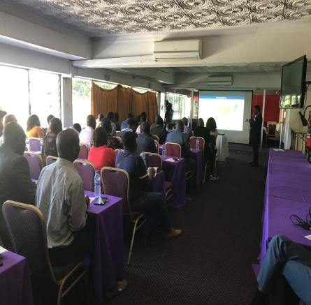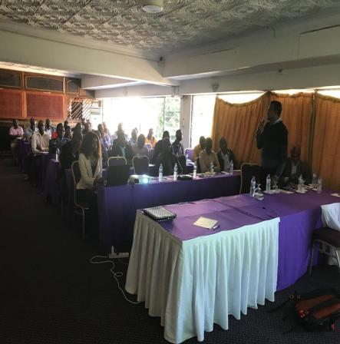
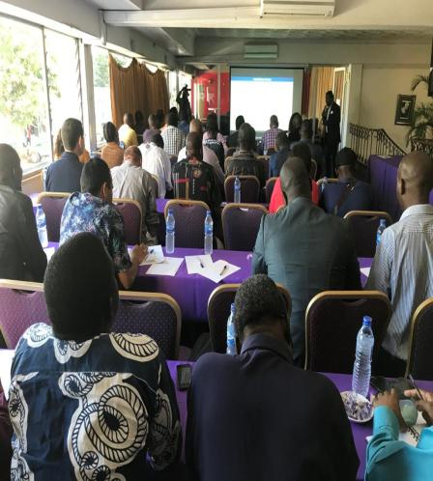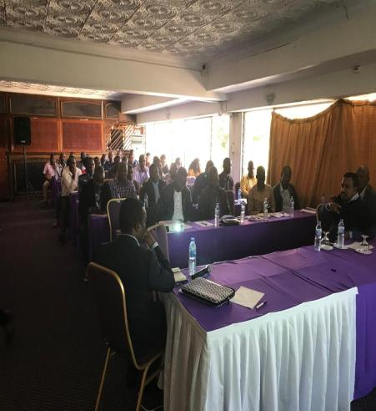

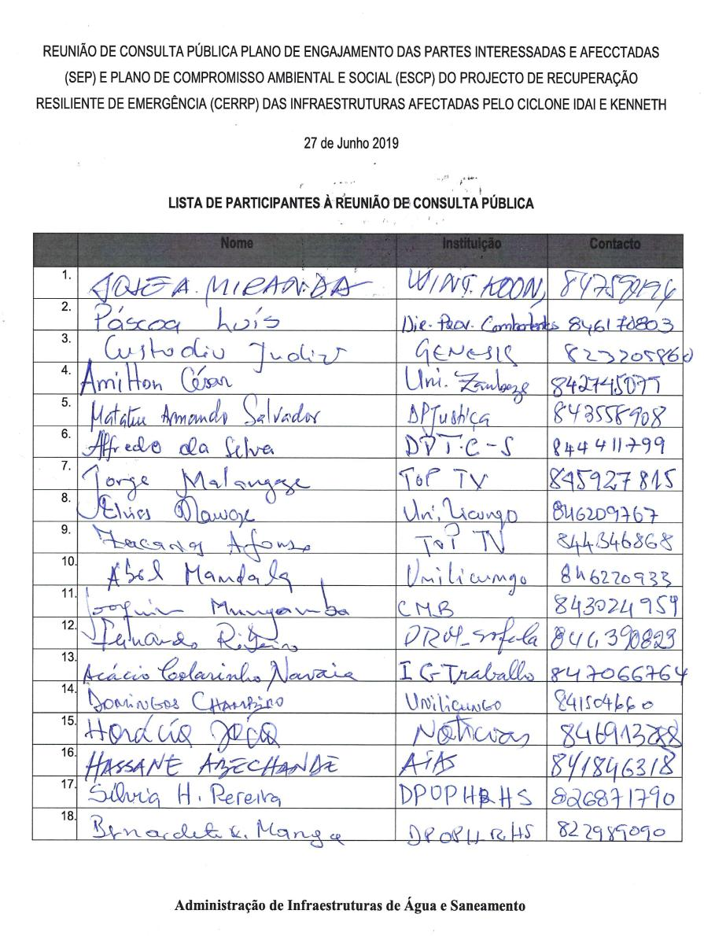

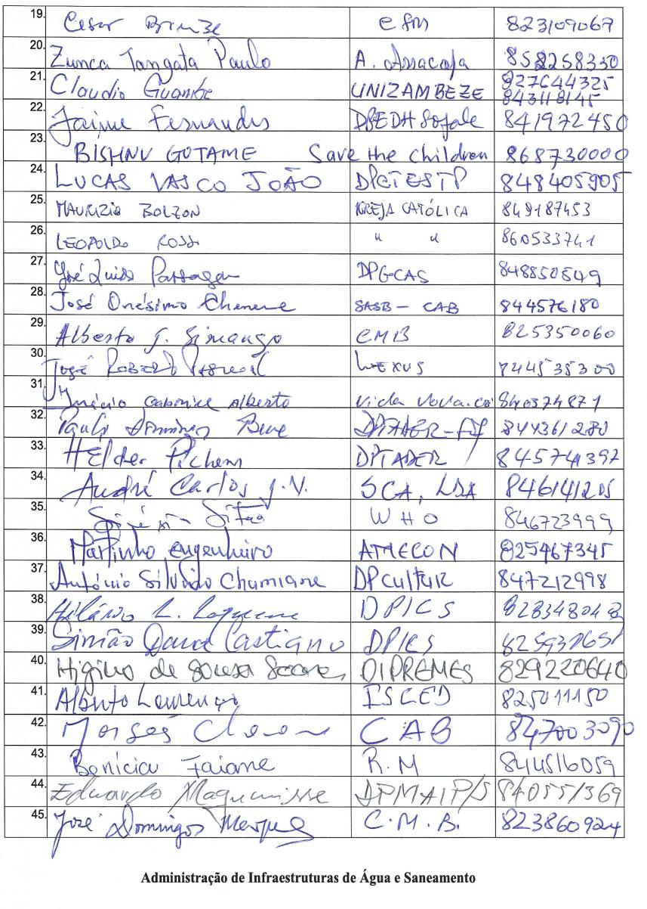

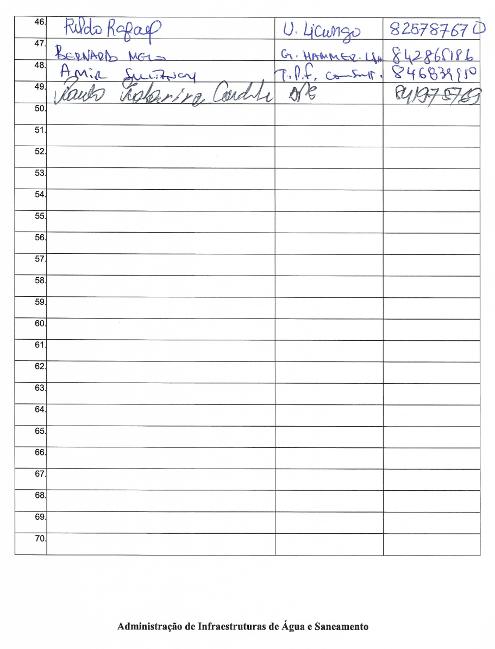

ANNEX 2 – Cost Estimate of ESHS preparation, supervision and implementation (Sep 2019)
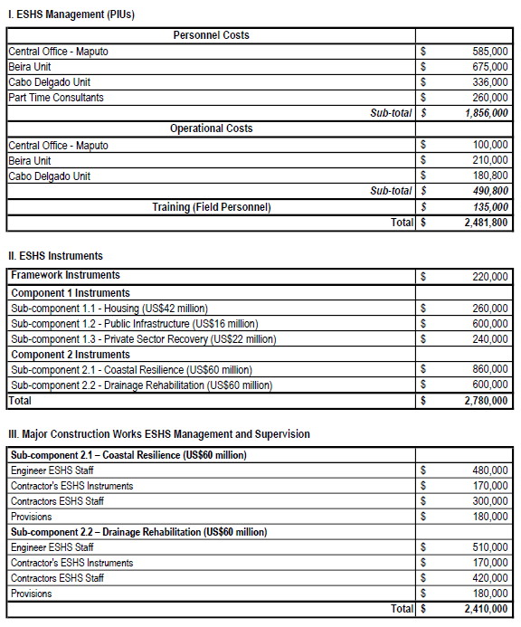

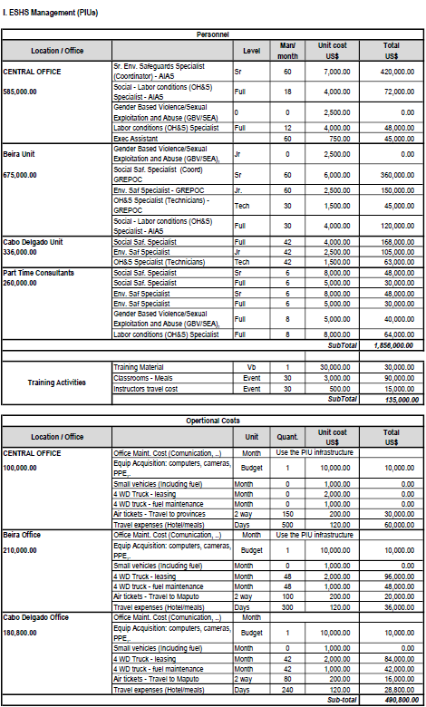
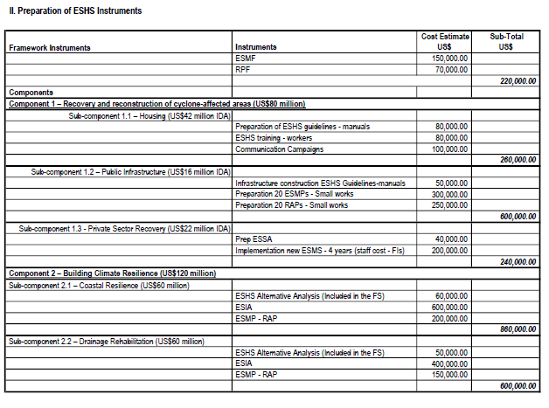

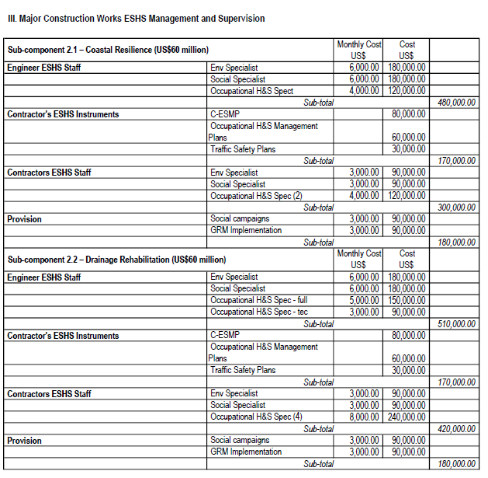

ANNEX 3 – PIU Organizational Chart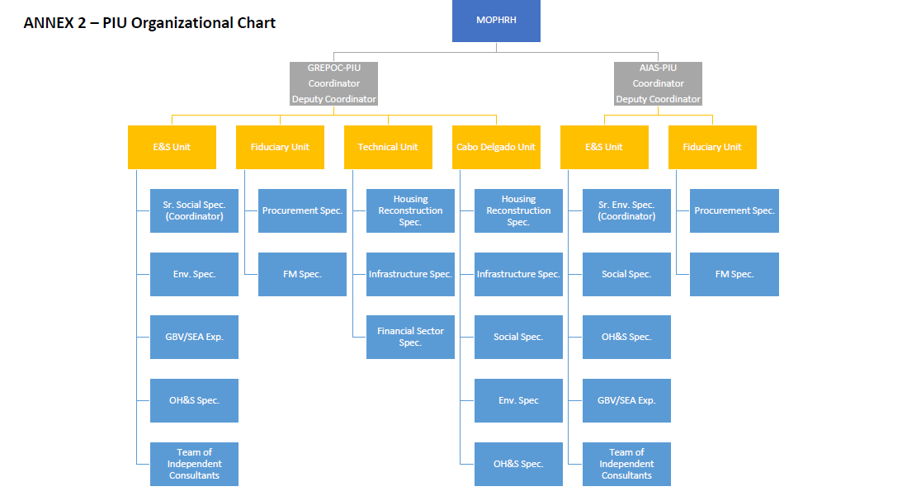

Government of Mozambique (2019) Post Disaster Need Assessment.
WHO Operational Support & Logistics Disease Commodity Packages – available at - https://www.who.int/publications-detail/disease-commodity-package---novel-coronavirus-(ncov)
World Bank, Environmental and Social Framework. Setting Environmental and Social Standards for Investment Project Financing, August 2016.

